Lebanese American University

School of Arts and Sciences

Department of Computer Science and Mathematics

A database design for the AMA Car Rental Company

By

Team 10:

**Adam Jardali**

(adam.jardali@lau.edu)

**Mohamad El Souki**

(mohammad.elsouki@lau.edu)

**Ayman Kandouli**

(ayman.kandouli@lau.edu)

A REPORT

submitted to Dr. Hussein Bakri in partial fulfillment of the requirements of phase 4 of the database project for the course CSC/BIF 375 – Database Management System

December 6th

Lebanese American University

School of Arts and Sciences

Department of Computer Science and Mathematics

A database design for the AMA Car Rental Company

Contents

1-Introduction 12

2-Tool(s)Used to Draw the ER 13

3-System Description and Requirements 13

4-Legend of ER Diagram Symbols 15

5. Complete ER Diagram for the AMA Car Rental Company 17

17

6.1-Relationships and their Attributes 18

18

6.2- Relationships and their Explanations 30

1. Works In 30

2. Manages 31

3. Identifies 31

6. Has 33

7. Is Maintained By 33

8. Is Cleaned By 34

9. Supervision 34

10. Dependents of 35

13. Signs 36

14. Shipped by 37

7- ER to Relational Mapping Algorithms 38

3- Contract (**Drafts**) 46

4- CAR (Is Cleaned by) 46

5- Car (Has) 47

9-Table Creations, Insertions and Queries 53

Queries 98

10- Normalization Up to the BCNF Form 106

11-Conclusion 123

12-Instructer’s feedback 124

13-Refrences 125

1-Introduction

Amidst the high rates of inflation, rising gas prices and low wages, three young men named Ayman, Mohamad and Adam decided to open a car rental company to lease cars to those who are not able to buy cars with reasonable prices. Since it was a small dealership, the three men decided to keep track of everything using a notebook. However, after they imported electric and hybrid cars to Lebanon, which presented a great alternative for petrol cars, they started to make substantial amount of profit. So, they started expanding and opening locations all around the MENA region.

After registering their company “AMA” as a publicly traded company, the shareholders insisted that everything must be digitized and stored into an online database which is more efficient and secure than a piece of paper.

This report describes the Car Rental Company main database design using an Entity-Relationship diagram. Sections two through five provide details about the tools, system requirements, and entities used to build the ER. And section six will discuss the entities of the ER along with their corresponding relationships. In the following sections, a mapping of the ER is done to give a good overview of the design with the goal of making the system easier to understand at a technical level. Then the database was created and filled with dummy data so that some queries would be executed it against it to test its functionality. And at last, the ER relations were normalized utilizing the first three normal forms, as well as the Boyce Codd normal form (BCNF) to create an efficient database.

2-Tool(s)Used to Draw the ER

Upon experimentation with multiple tools such as DIA, GitMind, and Draw.io, Draw.io was the preferred tool for constructing the Entity-Relationship Model. It was chosen due to its simplicity, ease of use, and lack of funds to use paid software such as Microsoft Visio.

3-System Description and Requirements

A car rental company is a corporation that leases vehicles to the public for brief periods, often lasting a couple of hours to a few weeks. The main dealership usually communicates with the company’s local branches, allowing users to return a car to a different location.

Each dealership branch has a location, name, and a unique number that identifies that branch from the other. Moreover, each branch must have employees, these employees are segregated into distinct categories. An employee needs to manage the dealership and the employees that work in the dealership need direct supervision. Furthermore, AMA understands the hardship of the current economic crisis, thus it rewards its employees with additional income for their dependents. The dependent’s name, age, date of birth, and relationship with the employee must be recorded for certain security reasons.

AMA tries to cater to its customers with all types of cars from normal family sedans to sports cars. However, not all cars are the same, each car can be uniquely identified by its VIN and license plate. Moreover, each car has a different type, color, and engine. The available cars are classified by their “age” and their “sturdiness,” the age of a car means when the car was produced, which can give the customer some expectations about its technologies. And its sturdiness can sometimes be determined by how far the car has been driven, hence it is important to keep track of each car’s year of production and mileage. Also, every time a car undergoes maintenance, it is recorded in the car fax which is given to the customer before renting the car so they can make sure of its safety.

As AMA tries to provide its customers with the highest quality cars, AMA has several suppliers that supply its need for cars, however each supplier is recorded separately using the name of their company. Furthermore, all the cars in the dealerships are maintained and cleaned by different companies which are classified by their distinct name, each specializing in a specific type of service due to the cars’ vast differences and needs.

The company provides customers with several insurance policy plans of different classes that allow the customers to choose whether they want to accept liability for any damage caused during the rental period, or a full coverage plan on the car that is being rented. Furthermore, because AMA allows its customers to pay policy fees in installments, it must keep track of the payment’s covered percentage. Finally, a unique insurance id is required for the company to keep track of each customer’s insurance policy.

While considering the security concerns in all the countries our companies operate in, the most valuable cars are kept in the countries that are deemed safer. And if a client requests a car that is not available in their country, AMA provides car shipping from country to country via third-party companies. However, AMA does not rent its highly valuable cars to any customer. Sometimes basic information such as the client’s unique SSN, name, address, phone number, email, sex, and date of birth may not be sufficient to offer a client a contract. Thus, AMA may hire several security companies that investigate the customers before offering them a contract. Where each security company provides a different type of service (known as security specialization) to AMA.

For each company that AMA hires, it prefers to store some of the contact information such as the distinguished name of said company, emails, phone numbers, and addresses in case they would like to hire them again.

After a client chooses a car and is deemed valid to be offered a contract, the process of renting one of AMA’s cars begins. While the dealership is drafting the contract, the contract must identify the car that the customer has selected and include a specific contract id, payment, start, and end date of the rental. In addition, the contract may include some discount according to the client types. After a client chooses a car and is deemed valid to be offered a contract, the process of renting one of AMA’s cars begins. While the dealership is drafting the contract, the contract must identify the car that the customer has selected and include the contract id, payment, start, and end date of the rental. In addition, the contract may include some discount according to the client types.

4-Legend of ER Diagram Symbols

|  |  |  |
| --- | --- | --- |
|  | Description | Shape |
| Entity | Green rectangle | Entity name |
| Weak Entity | Double green Rectangle | E-N |
| Relationship | Pink diamond | R-N |
| Identifying Relationship | Double Pink diamond | R-N |
| Attribute | blue oval |  |
| Key Attribute | blue oval with the attribute underlined |  |
| Multivalued  Attribute | A double blue oval |  |
| Derived Attribute | Dotted blue oval |  |
| Weak key Attribute | blue oval with a dotted line underneath the attribute name |  |
| One to Many | The line starts with one and ends with N |  |
| Many to Many | The line that starts with N and ends with M |  |
| Partial participation | Line with a single strip |  |
| Total participation | Line with double strips |  |

5. Complete ER Diagram for the AMA Car Rental Company

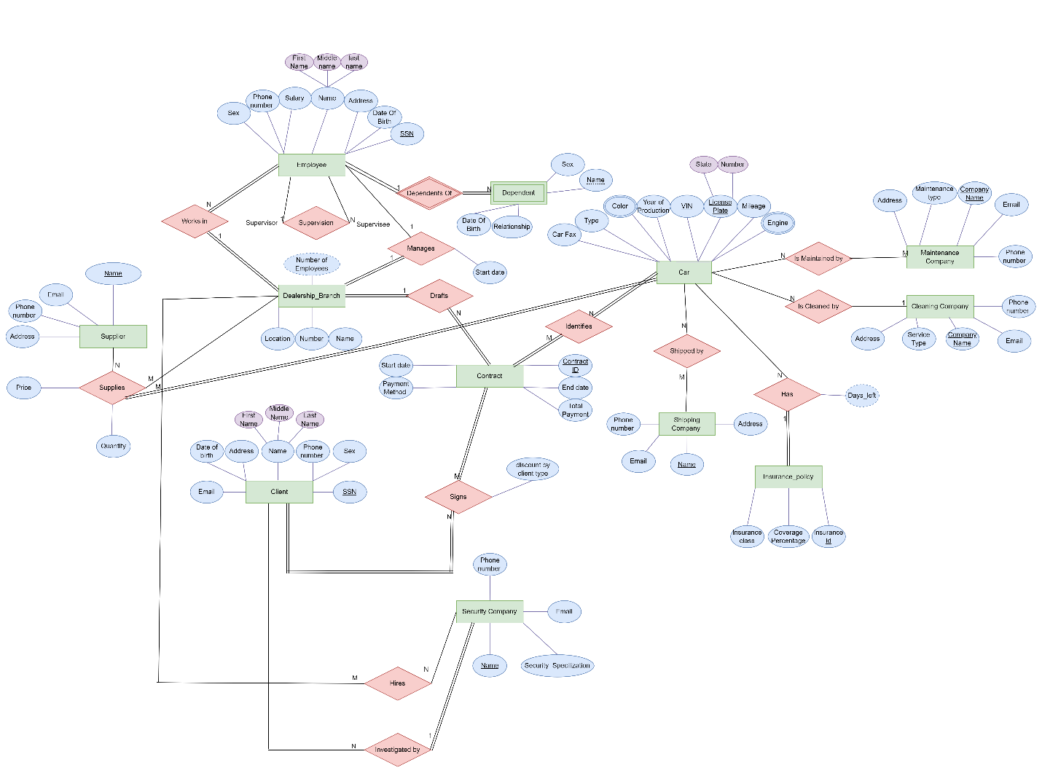

6.1-Relationships and their Attributes

1. **Car:**

The car entity is the core of the AMA company because, without cars, AMA would not be able to operate. A car is defined as “a four-wheeled vehicle designed primarily for passenger transportation” (Cromer, 2022). However, not all cars are the same, each car can be uniquely identified by its VIN and license plate. Moreover, each car has a different type, color, and engine. The available cars are classified by their ”age” and their “sturdiness,” the age of a car means when the car was produced, which can give the customer some expectations about its technologies. And its sturdiness can sometimes be determined by how far the car has been driven, hence it is important to keep track of each car’s year of production and mileage. Also, every time a car undergoes maintenance, it is recorded in the car fax which is given to the customer before renting the car so they can make sure of its safety.

* VIN: It is the vehicle identification number that uniquely identifies each car; thus, it is a key attribute.
* License plate: It is specific to each car, and it usually contains the state the car is registered in including the plate number; thus, it is a key composite attribute.
* Type: A car can be of several types. For example, a car can be a 4X4, or it can be a sports car.
* Color: A car can be either of single or multiple colors at the same time. Thus, a car’s color is a multivalued attribute.
* Engine: Cars can have different engines; a car can have a petrol engine or an electric engine. However, some cars have both types of engines. These cars are called hybrid cars. Therefore, the car’s engine is considered a multivalued attribute.
* Year of production: The year a car was produced.
* Mileage: How many miles has a car driven.

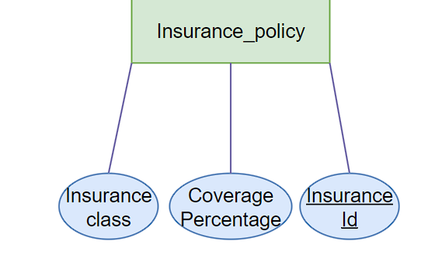

1. Insurance Policy:

Usually, companies are keen on the idea of risk management, AMA Company is no different from them, which is why they have offered an insurance policy plan for the customer, which lets the customer choose whether they want to take liability(class B) for any damage that is caused during the rental period, or a full coverage plan that insures the car that is being rent(class A). Moreover, AMA gives its customers the chance to pay the fees of the policy in installments, hence it needs to keep track of its covered percentage. An insurance id is required for the company to keep track of each customer’s insurance policy.

* Insurance ID: A key to keep track of the insurance.
* Insurance class: The type of insurance policy that the customer can purchase.
* Covered Percentage: The covered percentage of the insurance policy payment

1. Dealership Branch:

A dealership is a sub-department of the AMA company. After becoming a multinational company, AMA decided to label its branches. Each branch has a different location, but all dealerships have the same name, but some of the branches are close to each other which means that they can be considered in the same location which forced AMA to give each dealership a unique number to avoid confusion while calculating profits and expenses of each branch.

* Name: Each dealership has a name
* Location: Each dealership has a different location than the other.
* Number: Since each dealership is under the same name, a number uniquely identifies the dealership, hence it is a key attribute.
* Number of employees: derived attribute.

1. Employee:

The dealership has several employees working for it regardless of their roles. So, it is important to keep track of certain information about these employees for security and work-related reasons. The dealership should keep track of each employee’s name, date of birth, SSN, address, phone number, and sex. It should also keep track of their salaries to calculate its expenses.

* Name: The employee’s name is saved as first name, middle name, and family name; thus, the name is considered as a composite attribute.
* Date of birth: To calculate the employee’s age
* SSN: Social Security that uniquely identifies the employee (key attribute).
* Address: It describes the employee’s address.
* Phone number: It contains the phone number of each employee.
* Sex: It contains the gender of the employee.
* Salary: It holds the value of the salary of the employee.

1. Dependent:

A dependent is a weak entity that depends on the presence of an employee, and their presence could provide the employee with certain benefits, thus it is important to keep track of their name, sex, date of birth, and their relationship to the employee.

* Name: Weak key entity that identifies the dependent.
* Date of birth: To calculate the client’s age
* Sex: It contains the gender of the client.
* Relationship: Specifies the relationship between the dependent and the employee.

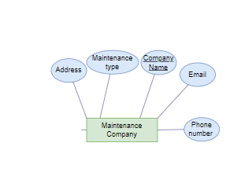

1. Maintenance Company:

Due to the huge variances in automobiles, AMA strives to give the greatest quality cars to its clients. All the cars in the dealerships are maintained by different firms, each with a unique name, specializing in a different maintenance type. Furthermore, AMA saves the contact information of each company it works with.

* Company Name: Key attribute that holds the company’s name and uniquely identifies it.
* Maintenance type: Specifies the type of service that will be performed on the car.
* Address: Stores the address of the maintenance company
* Email: Stores the email of the maintenance company
* Phone number: Stores the phone number of the maintenance company

1. Cleaning Company:

AMA tries its best to provide the highest quality cars for its customers, therefore they have different companies with different names that clean their cars in several ways (service type). Furthermore, AMA saves the contact information of each company it works with.

* Name: Key attribute that holds the company’s name and uniquely identifies it.
* Service type: Specifies the type of cleaning that will be performed on the car.
* Address: Stores the address of the maintenance company
* Email: Stores the email of the maintenance company
* Phone number: Stores the phone number of the maintenance company

1. Shipping Company:

If a client wants a car that is not offered in their country, AMA offers car shipment from country to country through third-party firms each with a different name. Each company’s contact information is stored in the database.

* Name: Key attribute that holds the company’s name and uniquely identifies it.
* Address: Stores the address of the maintenance company
* Email: Stores the email of the maintenance company
* Phone number: Stores the phone number of the maintenance company

1. Supplier:

To supply AMA’s car needs, several suppliers provide the dealership with cars. Each supplier is identified by their name and their contact information is stored.

* Name: Key attribute that holds the company’s name and uniquely identifies it.
* Address: Stores the address of supplier
* Email: Stores the email of the supplier
* Phone number: Stores the phone number of the supplier

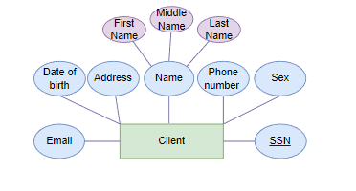

1. Client:

The client is what keeps AMA’s business running. When a client comes to lease a car, information such as their name, SSN, email, date of birth, sex, address, and phone number are stored

* Name: The client’s name is saved as first name, middle name, and family name; thus, the name is considered as a composite attribute.
* Date of birth: To calculate the client’s age
* SSN: Social Security that uniquely identifies the client (key attribute).
* Address: It describes the client’s address.
* Phone number: It contains the phone number of each client.
* Sex: It contains the gender of the client.
* Email: Contains the client’s email

1. Security Company:

AMA does not lease its high-value vehicles to any client. It employs a security company to investigate the client before offering them a contract. AMA might hire different companies to do several types of investigations (financial check, background check...) .The security company is uniquely identified by its name and its contact information is stored.

* Name: Key attribute that holds the company’s name and uniquely identifies it.
  + Security Specialization: Specifies the type of investigation that will be performed on the client.
  + Address: Stores the address of the company.
  + Email: Stores the email of the company.
  + Phone number: Stores the phone number of the company.

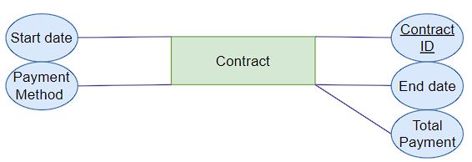

1. Ccontract:



The contract that the client signs is identified by its id. It also specifies the start and end date of the car rental, in addition to the total payment to be made with the client’s preferred payment type.



* + Contract id: Key attribute that uniquely identifies the contract, to avoid confusion with other contracts if the same customer rented different cars.
  + Start date: Specifies the first day of the rental period.
  + End date: Specifies the last day of the rental period.
  + Total payment: Specifies the due amount that the client must pay
  + Preferred payment type: Specifies in which way will the client settle their payments (cash or credit).

6.2- Relationships and their Explanations

1. 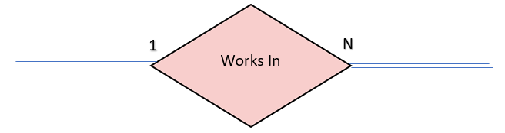 Works In

**Many** employees work for **each** Dealership. Thus a “WORKS IN” relationship must exist between the **employee** entity and the **dealership** entity. The participation on both sides is total since all Employees work for a dealership and all dealerships have employees working for them.

1. Manages

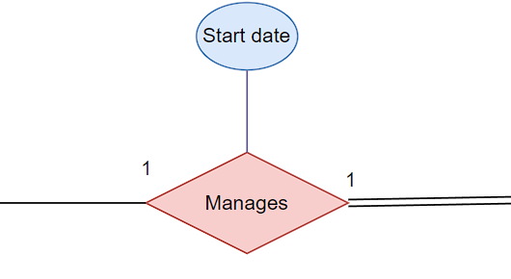

There exists only one **employee** that manages a **dealership**. Also, exactly one employee manages each dealership. Thus a “**Manages**” relationship must exist between the **employee** entity and the **dealership** entity. The participation of the dealership is total since all dealerships have employees managing them.

1. 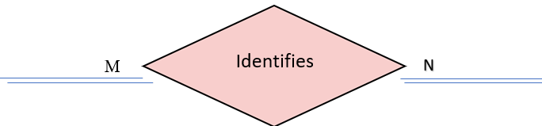Identifies

A contract can identify several cars, and each **car** can be identified by several contracts**.** Thus an “**Identifies**” relationship must exist between the **contract** entity and the **car** entity. The participation of both sides is total since all contracts must specify a car and each car should be mentioned in a contract before it is leased.

1. 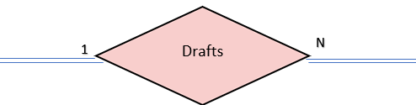Drafts

Each department drafts a **contract,** and many **contracts** are drafted by a **department**. Thus a “drafts” relationship must exist between the department and contract entities. The participation

1. 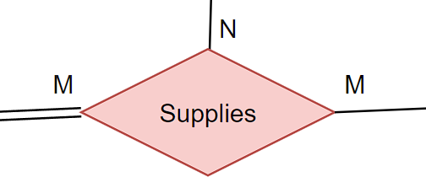Supplies

Each **Supplier** supplies **cars** to the dealership and each **Dealership Branch** has many suppliers supplying **cars** to it.Thus, a ternary “**Supplies**” relationship must exist between the **Supplier** entity, **car** entity, and **dealership** entity. The participation of the **Dealership Branch** is partial since a **Supplier** may not supply cars to the **Dealership Branch** and the **Dealership** **Branch** may not be supplied by cars from a **Supplier**. However, a certain Supplier must supply each Car.

1. 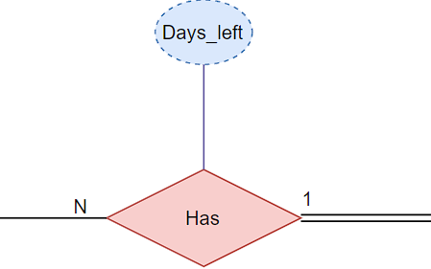Has

Each **Car has** an insurance policy, and Each **Insurance Policy** has many cars benefiting from it.Thus a “**has**” relationship must exist between the **Car** entity and the **Insurance Policy** entity. The participation of the **Car** entity is partial since a car may be without an insurance policy, but the participation of **Insurance Policy** is total because each **Insurance Policy** has a car benefiting from it.

1. 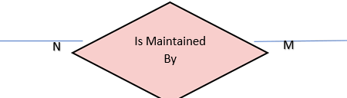Is Maintained By

Different maintenance companies and each maintenance company can maintain each car maintains several cars.Thus an “**Is Maintained By**” relationship must exist between the **Car** entity and the **Maintenance company** entity. The participation of both sides is partial since a car may not always undergo maintenance, and the maintenance company may not always be maintaining a car.

1. **A picture containing text, clipart, businesscard

   Description automatically generated**Is Cleaned By

A cleaning company and each cleaning company clean each car has many cars that it cleans.Thus a “**Is Cleaned by**” relationship must exist between the **car** entity and the **cleaning** **company** entity. The participation of both sides is partial since the car may not be cleaned and the cleaning company may not always be cleaning a car.

1. 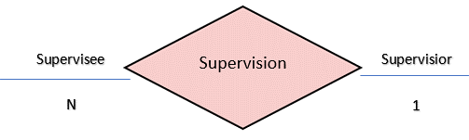Supervision

Each Employee plays the role of a supervisor to many employees and each employee who plays the role of a supervisee has only one supervisor. Thus, the relations “**Supervisor**” and “**Supervisee**” must exist. This is a recursive relation on the employee entity.

1. 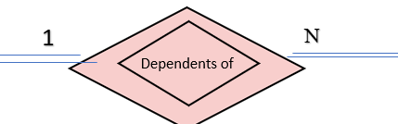Dependents of

Each Employee may have zero to many dependents and each dependent belongs to exactly one employee. Thus a “Dependents Of” relationship exits with total participation of both participants in the relationship.

1. Hires

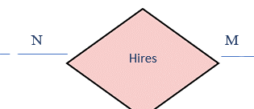



The dealership can hire many security companies to investigate some customers and a security company can be hired by several dealerships. Thus, there must exist a “hires” relationship between the dealership and security company entities. A dealership usually can hire several companies and a single company can be hired by several dealership branches. The participation is partial from both sides of the relationship because the dealership might not always hire a security company and a security company is not always hired by a dealership.

1. Investigated by

A security company investigates some clients, and a client is investigated by security companies. Thus, there must exist a “investigated by” relationship between the client and security company entities. A security company usually investigates several clients, but a client is investigated by one company. The participation is partial from both sides of the relationship because the security company may not always investigate a client and a client.

1. A picture containing chart

   Description automatically generatedSigns

Each client signs a contract, and each contract is signed by a client. Thus, a “Signs” relationship must exist between the client and contract entities. Each client can sign multiple contracts, and each contract can be signed by more than one client. Moreover, the participation from both ends in this relationship is total where every client must sign a contract and each contract must be signed by a client.

1. 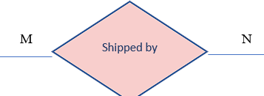Shipped by

A car that is not available in a certain branch is shipped by a shipping company upon request and a shipping company ships that car. Thus a “Shipped by” relationship must exist between the **Car entity** and the **Shipping** **Company** entity. A car may be shipped by different companies and a shipping company can ship many cars. Moreover, the participation of the participating entities in this relationship is partial since a car may not be shipped by a shipping company and a shipping company may not ship a car.

7- ER to Relational Mapping Algorithms

After designing the ER schema of the car rental company, it is time to map this ER into a relational database. To do this, a seven-step algorithm needs to be followed. Hence the following is a detailed description of how we applied the different steps to our database design.

**Step1: Mapping of Regular Entity Types:**

In this step, the regular entity type should be mapped to relations. Each of those entity types has its own relation where only key and single attributes are displayed in it. The database includes EMPLOYEE, DEALERSHIP BRANCH, CLIENT, CONTRACT, CAR, MAINTENANCE COMPANY, CLEANING COMPANY, SHIPPING COMPANY, SECURITY COMPANY, SUPPLIER, AND INSURANCE POLICY as regular entity types.

1. Table

   Description automatically generatedEMPLOYEE

The EMPLOYEE entity has simple and composite attributes. This relation includes all simple attributes and the primary key SSN which is underlined. The EMPLOYEE entity has Name as a composite attribute of which only the simple attributes Fname, Mname, Lname are included in this relation. DNum and SuperSSN will be discussed in step 4.

1. Table

   Description automatically generatedDEALERSHIP_BRANCH

The DEALERSHIP_BRANCH entity has three simple attributes. This relation includes all simple attributes, and its primary key Number is underlined. The derived attribute Number of employees is not represented in this relation. MgrSSN and Mgr_Start_Date will be discussed in step 3.

1. 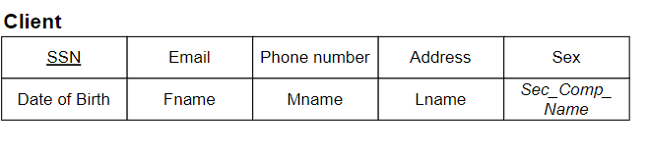CLIENT

The CLIENT entity has simple and composite attributes. This relation includes all simple attributes and the primary key SSN which is underlined. Sec_Comp_Name will be discussed in step 4.

1. **Table

   Description automatically generated**CONTRACT

The CONTRACT entity has only five simple attributes. This relation includes all simple attributes and the primary key Contract ID which is underlined. DNum will be discussed in step 4.

1. 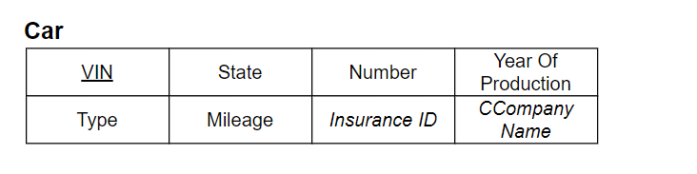CAR

The CAR entity contains simple, composite, and multivalued attributes. The CAR entity has License plate as a composite attribute of which only the simple attributes state and number are included in the relation. This relation includes all simple attributes and the primary keys VIN, State, and Number which are underlined. The multivalued attributes Color and Engine are not represented in this relation. Insurance_ID and CCompanyName will be discussed in step 4.

1. A picture containing diagram

   Description automatically generatedMAINTENANCE_COMPANY

The MAINTENANCE_COMPANY entity has only 5 simple attributes. This relation includes all simple attributes and the primary key Company Name which is underlined.

1. CLEANING_COMPANY

The CLEANING_COMPANY entity has only five simple attributes. This relation includes all simple attributes and the primary key Company Name which is underlined.

1. Table

   Description automatically generated with medium confidenceSHIPPING_COMPANY

The SHIPPING_COMPANY entity has only four simple attributes. This relation includes all simple attributes and the primary key Name which is underlined.

1. Table

   Description automatically generated with medium confidenceSECURITY_COMPANY

The SECURITY_COMPANY entity has only 4 simple attributes. This relation includes all simple attributes and the primary key Name which is underlined.

1. Timeline

   Description automatically generated with low confidence SUPPLIER

The SUPPLIER entity has only 4 simple attributes. This relation includes all simple attributes and the primary key Name which is underlined.

1. INSURANCE_POLICY

The INSURANCE_POLICY entity has only 3 simple attributes. This relation includes all simple attributes and the primary key Insurance ID which is underlined.

**Step 2: Mapping of Weak Entity Types:**

The weak entity is mapped in this step. Only the key and simple attributes are displayed, as with strong entities; however, there is no single key attribute, which is what distinguishes it as a weak entity. A foreign key is a primary key attribute for the weak entity type relation in the weak entity. In this ER we only have one weak entity which is DEPENDENT.

1. A picture containing text

   Description automatically generatedDEPENDENT

The DEPENDENT entity has four simple attributes. The attribute ESSN, which is a foreign key, is a primary key of the EMPLOYEE relation. The partial key Name and the foreign key ESSN form the primary key of the weak entity Dependent. Relationship, Sex, and Date of birth are simple attributes.

**Step 3: Mapping of Binary 1:1 Relationships:**

We will map the binary one-to-one relationships in this step. To achieve our goal, we can take one of three approaches. The first approach, known as the foreign key approach, selects the entity with complete participation in the relation, and then selects the primary key of the other entity as a foreign key. The second approach, known as the merged relation approach, involves combining the two entities involved in the relationship into a single relation. The third approach, known as a cross-reference/relationship relation, includes the primary keys of both entity types in the relation. We will use the foreign key approach because it is the most practical in our situation.

1. Dealership Branch (Manages)

Every Dealership has a manager which is an employee. Thus, there exists a “Manages” relationship between DEALERSHIP_BRANCH entity and the EMPLOYEE entity. The DEALERSHIP_BRANCH has total participation thus we added to the DEALERSHIP_BRANCH relation the foreign key SSN which is a primary key in the EMPLOYEE relation and named it as “MgrSSN.”

**Step 4: Mapping of 1 :N Relationships:**

We will map the binary one-to-many relationships in this step. In this relation, we add the primary key of the other entity as a foreign key for the entity of "many" participation.

1. Table

   Description automatically generatedEmployee (Supervision)

Every Employee who plays the role of the supervisee has a supervisor in the EMPLOYEE entity and every employee who plays the role of a supervisor, supervises many employees. Thus, there exists a **“Supervision”** relationship between EMPLOYEE entity and itself.We add to the EMPLOYEE relation the foreign key SSN in reference to the supervisor in this entity and rename it as SuperSSN. (check)

1. Table

   Description automatically generatedEmployee (Works in)

Every Dealership has many employees working in it. Thus, there exists a **“Works_in”** relationship between EMPLOYEE entity and the DEALERSHIP_BRANCH entity. We add to the EMPLOYEE entity the foreign key Number which is the primary key of DEALERSHIP_BRANCH entity since EMPLOYEE is on the “many” side and rename it as DNum.

1. **Table

   Description automatically generated**Contract (**Drafts**)

Every Dealership drafts many contracts. Thus, there exists a “**Drafts”** relationship between DEALERSHIP_BRANCH entity and the CONTRACT entity. We added to the CONTRACT entity the foreign key Number which is the primary key of dealership entity since CONTRACT is on the “many” side and rename it as DNUM.

1. Table

   Description automatically generatedCAR (Is Cleaned by)

One or more cleaning company cleans every Car. Thus, there exists an “**Is Cleaned by”** relationship between the CAR entity and the CLEANING_COMPANY entity. We add to the CAR entity the foreign key Company Name which is the primary key of CLEANING_COMPANY entity since CAR is on the “many” side and rename it as CCompanyName.

1. Table

   Description automatically generatedCar (Has)

Every car has an insurance policy. Thus, there exists a **“Has”** relationship between the CAR entity and the INSURANCE_POLICY entity. We add to the CAR entity the foreign key Insurance ID which is the primary key of INSURANCE_POLICY entity since CAR is on the “many” side.

1. Table

   Description automatically generatedClient (Investigated by)

Every Security Company investigates many Clients. Thus, there exists an “**Investigated by”** relationship between the CLIENT entity and the SECURITY_COMPANY entity. We add to the CLIENT entity the foreign key Name which is the primary key of the SECURITY_COMPANY entity since CLIENT is on the “many” side and rename it as Sec_Comp_Name.

**Step 5: Mapping of N:M Relationships:**

In order to map many to many relationships, the relation should contain the primary of each entity and other simple attributes of the relationship if they exist.

1. A picture containing table

   Description automatically generatedIdentifies

Many Cars get identified by many contracts and vice versa. Thus, there exists an **“Identifies”** relationship between the CONTRACT entity and the CAR entity. The relation includes the primary key of the CONTRACT entity which is Contract ID and the primary key of the CAR entity which is VI N. The combination of the added keys forms the primary key of the “Identifies” relationship and thus they are underlined.

1. 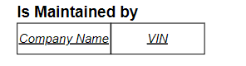Is Maintained by

Many Maintenance Companies maintain many Cars. Thus, there exists an **“Is_Maintained_by”** relationship between the MAINTENANCE_COMPANY entity and the CAR entity. The relation includes the primary key of the MAINTENANCE_COMPANY entity Company Name and the primary key of the CAR entity VIN. The combination of the added keys forms the primary key of the “Is_Maintained_by” relationship and thus they are underlined.

1. 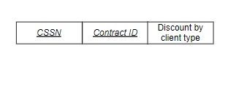Signs

Many Clients signs many Contracts. Thus, there exists a **“Signs”** relationship between the CLIENT entity and the CONTRACT entity. The relation includes the primary key of the CONTRACT entity which is Contract ID and the primary key of the CLIENT entity SSN renamed as CSSN. The combination of the added keys forms the primary key of the Signs relationship and thus they are underlined. The relationship “Signs” has a simple attribute Discount by client type which is represented in this relation.

1. 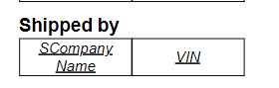Shipped by

Many Cars get Shipped by many Shipping Companies and vice versa. Thus, there exists a **“Shipped_by”** relationship between the SHIPPING_COMPANY entity and the CAR entity. The relation includes the primary key of the SHIPPING COMPANY entity Name which renamed as SCompanyName and the primary key of the CAR entity. The combination of the added keys forms the primary key of the “Shipped_by” relationship and thus they are underlined.

1. Hires

Many Dealerships hire many Security Companies and vice versa. Thus, there exists a **“Hires”** relationship between the DEALERSHIP_BRANCH entity and the SECURITY_COMPANY entity. The relation includes the primary key of the DEALERSHIP_BRANCH entity Number which is renamed as DNUM and the primary key of the SECURITY_COMPANY entity Name renamed as SCName. The combination of the added keys forms the primary key of the “Hires” relationship and thus they are underlined.

**Step 6: Mapping of Multivalued Attributes:**

In this step we will create relations that will include the attributes of the multivalued attributes in addition to the primary key of the entity type. The resulting combination will be the primary key of the newly created relation.

1. Table, box and whisker chart

   Description automatically generatedCar Engine

To map the multivalued attribute Engine, a “Car Engine” relation was created. The primary key of this relation is composed of Engine representing the multivalued attribute and the primary keys of the CAR entity State. The combination of the added keys forms the primary key of the “Car Engine” relationship and thus they are underlined.

1. Chart, box and whisker chart

   Description automatically generatedCar Color

To map the multivalued attribute Color, a “Car Color” relation was created. The primary key of this relation is composed of Color representing the multivalued attribute and the primary keys of the CAR entity. The combination of the added keys forms the primary key of the “Car Color” relationship and thus they are underlined.

**Step 7: Mapping of N-ary Relationship Types:**

In this step, the N-ary relationship type should be mapped. A new relation containing the primary keys of all participating entities and any simple attribute of the relationship type is created, where the combination of the primary keys is this relation’s primary key.

1. Text

   Description automatically generated with low confidenceSupplies

There exists a ternary relationship “Supplies” between DEALERSHIP_BRANCH entity, CAR entity, and the SUPPLIER entity. Thus, the primary key of the “Supplies” relation is composed of the primary key of SUPPLIER entity Name renamed as SName, the primary keys of the CAR entity. The primary key of the DEALERSHIP_BRANCH entity Number named as DNUM.

9-Table Creations, Insertions and Queries

CREATE TABLE EMPLOYEE

(

E_SSN CHAR(11) NOT NULL,

E_PHONE_NUMBER VARCHAR (12) NOT NULL,

E_SALARY INTEGER NOT NULL,

E_ADDRESS VARCHAR (50) NOT NULL,

E_SEX CHAR(1) CHECK( E_SEX in ('M','F')) NOT NULL,

E_DOB DATE NOT NULL,

E_FNAME VARCHAR (20) NOT NULL,

E_MNAME VARCHAR (20) NOT NULL,

E_LNAME VARCHAR (20)NOT NULL,

DNUM INTEGER NOT NULL,

SUPERSSN CHAR (11),

CONSTRAINT PK_ESSN PRIMARY KEY (E_SSN),

CONSTRAINT FK_SSSN FOREIGN KEY (SUPERSSN) REFERENCES EMPLOYEE (E_SSN)

)

INSERT INTO EMPLOYEE VALUES('876-86-2979','758-347-2687',1019,'7902 Cody Crossing','F',DATE'2000-12-10','Stefano','Filberto','Mead',4967604811,NULL)

INSERT INTO EMPLOYEE VALUES('703-39-9694','382-396-2543',9544,'8 Prentice Drive','M',DATE'1965-05-20','Wiley','Angelia','Care',8311316260,NULL);

INSERT INTO EMPLOYEE VALUES('365-88-9871','458-703-3124',7204,'8 Declaration Place','M',DATE'1974-10-23','Dael','Cynde','Eliot',9166069157,'876-86-2979');

INSERT INTO EMPLOYEE VALUES('596-31-6922','480-112-3970',1111,'15511 Carpenter Point','F',DATE'1998-01-24','Marnie','Rodolfo','Mead',5841962051,'876-86-2979');

INSERT INTO EMPLOYEE VALUES('523-18-6661','572-472-5390',4044,'36 Cascade Avenue','M',DATE'1990-09-12','Agustin','Catha','Chandler',8568922309,'876-86-2979');

INSERT INTO EMPLOYEE VALUES('429-46-7711','430-345-5093',4618,'5 Pierstorff Trail','M',DATE'1980-08-19','Gal','Saxon','Marnie',3233201168,'876-86-2979');

INSERT INTO EMPLOYEE VALUES('537-78-6694','924-376-6394',6221,'202 Derek Center','M',DATE'2000-11-03','Brockie','Claudette','Kris',5507654247,'876-86-2979');

INSERT INTO EMPLOYEE VALUES('181-42-7396','182-511-6033',1866,'9759 Old Gate Way','M',DATE'2000-08-17','Reilly','Eal','Kerry',6934445473,'876-86-2979');

INSERT INTO EMPLOYEE VALUES('404-20-0225','432-617-7274',8465,'3 Kensington Hill','M',DATE'1984-08-10','Thaddeus','Flo','Lucilia',6607525660,'271-63-5967');

INSERT INTO EMPLOYEE VALUES('762-57-7792','289-429-6028',3594,'8 Raven Place','M',DATE'1982-04-20','Karoline','Wendye','Cchaddie',1684468604,'271-63-5967');

INSERT INTO EMPLOYEE VALUES('282-74-5136','246-929-8951',1304,'3062 Texas Way','M',DATE'1960-18-03','Hewe','Neddy','Care',8581580904,'271-63-5967');

INSERT INTO EMPLOYEE VALUES('384-99-8649','911-786-7453',3854,'15511 Carpenter Point','F',DATE'2001-08-26','Bree','Dedra','Jilli',572576730,'271-63-5967');

INSERT INTO EMPLOYEE VALUES('617-54-8955','289-429-6028',2508,'7902 Cody Crossing','M',DATE'1997-10-19','Cully','Cully','Wenonah',5602894152,'271-63-5967');

INSERT INTO EMPLOYEE VALUES('235-27-7224','874-728-8251',2386,'04219 Moulton Circle','F',DATE'1991-07-19','Benjy','Reilly','Kriste',9701248996,'703-39-9694');

INSERT INTO EMPLOYEE VALUES('290-75-7924','458-703-3124',9387,'3 Kensington Hill','M',DATE'1970-07-16','Eal','Jeno','Giacobo',2050974124,'703-39-9694');

INSERT INTO EMPLOYEE VALUES('747-72-2546','165-841-4616',9606,'11212 Arizona Center','F',DATE'1999-12-13','Althea','Dario','Wiley',6835880120,'703-39-9694');

INSERT INTO EMPLOYEE VALUES('658-78-5009','360-479-3219',6317,'753 Evergreen Circle','F',DATE'2000-Jul-15','Brockie','Emelina','Darlleen',8797050601,'703-39-9694');

INSERT INTO EMPLOYEE VALUES('610-63-9600','450-141-0537',9387,'9511 Homewood Way','M',DATE'1980-01-27','Emelina','Aguistin','Darleen',3610826126,'703-39-9694');

INSERT INTO EMPLOYEE VALUES('819-75-3652','725-660-8460',9577,'51 Manitowish Hill','M',DATE'1999-12-11','Sheppard','Chandler','Jilli',5213005675,'703-39-9694');

INSERT INTO EMPLOYEE VALUES('876-86-2979','758-347-2687',1019,'7902 Cody Crossing','F',DATE'1999-03-08','Stefano','Filberto','Mead',4967604811,NULL);

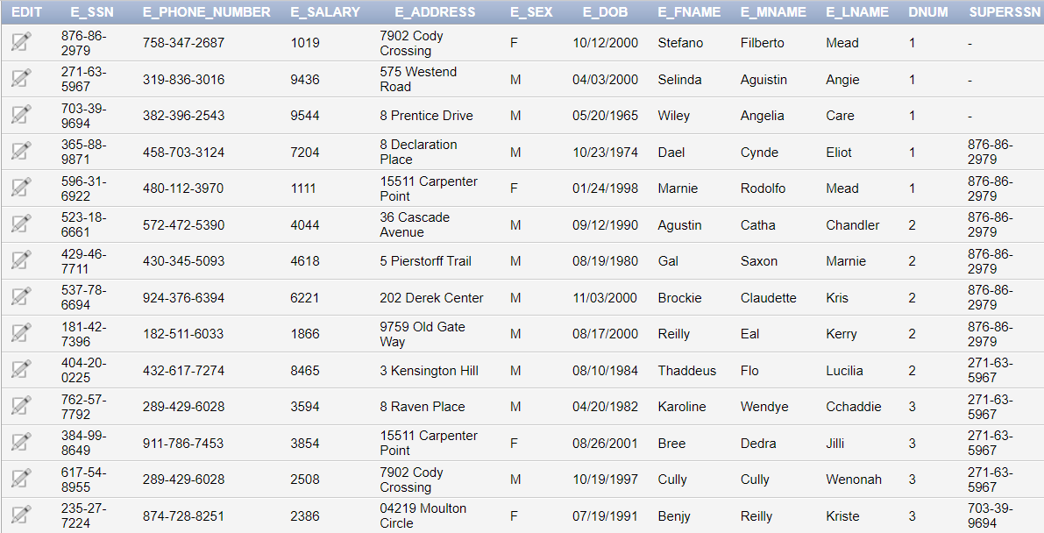



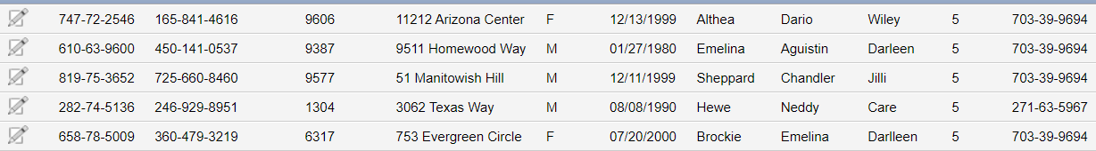

CREATE TABLE DEALERSHIP_BRANCH

(

DB_NUMBER INTEGER NOT NULL,

DB_LOCATION VARCHAR(70) NOT NULL,

DB_NAME VARCHAR(70) NOT NULL,

MGRSSN CHAR(11) NOT NULL,

MGR_START_DATE DATE NOT NULL,

CONSTRAINT PK_DB_NUMBER PRIMARY KEY (DB_NUMBER),

CONSTRAINT MGRSSN_FK FOREIGN KEY (MGRSSN) REFERENCES EMPLOYEE (E_SSN)

)

INSERT INTO DEALERSHIP_BRANCH Values(4967604811,'699 Calypso Parkway','Spencer Group','876-86-2979',DATE'2006-07-26');

INSERT INTO DEALERSHIP_BRANCH Values(4571609353,'616 Rieder Point','Funk-Thiel','271-63-5967',DATE'2007-01-05');

INSERT INTO DEALERSHIP_BRANCH Values(8311316260,'0 Susan Hill','Luettgen-Gutkowski','703-39-9694',DATE'2010-07-15');

INSERT INTO DEALERSHIP_BRANCH Values(9166069157,'8 Goodland Court','Sauer Group','365-88-9871',DATE'2000-09-01');

INSERT INTO DEALERSHIP_BRANCH Values(5841962051,'2111 Mallory Place','"Kessler, Miller and Pfeffer"','596-31-6922',DATE'2009-05-29');

INSERT INTO DEALERSHIP_BRANCH Values(8568922309,'9759 Old Gate Way','"Hoppe, Stanton and Rippin"','523-18-6661',DATE'2008-01-31');

INSERT INTO DEALERSHIP_BRANCH Values(3233201168,'21036 Meadow Ridge Park','Leffler-Feeney','429-46-7711',DATE'2000-01-20');

INSERT INTO DEALERSHIP_BRANCH Values(5507654247,'9 Linden Avenue','Bartell-Wilkinson','537-78-6694',DATE'2005-02-23');

INSERT INTO DEALERSHIP_BRANCH Values(6934445473,'76949 Eastwood Way','Dach-Prosacco','181-42-7396',DATE'2003-08-08');

INSERT INTO DEALERSHIP_BRANCH Values(6607525660,'8 Nova Drive','Bechtelar-Mueller','404-20-0225',DATE'2004-05-15');

INSERT INTO DEALERSHIP_BRANCH Values(1684468604,'282 Knutson Drive','Casper Inc','762-57-7792',DATE'2000-10-15');

INSERT INTO DEALERSHIP_BRANCH Values(8581580904,'57 Lien Crossing','Bechtelar-Carter','282-74-5136',DATE'2006-07-12');

INSERT INTO DEALERSHIP_BRANCH Values(572576730,'47 Reinke Hill','Bartell-Wilkinson','384-99-8649',DATE'2000-09-16');

INSERT INTO DEALERSHIP_BRANCH Values(1,'699 Calypso Parkway','Spencer Group','876-86-2979',DATE'2006-07-26');  
INSERT INTO DEALERSHIP_BRANCH Values(2,'616 Rieder Point','Funk-Thiel','271-63-5967',DATE'2007-01-05');  
INSERT INTO DEALERSHIP_BRANCH Values(3,'0 Susan Hill','Luettgen-Gutkowski','703-39-9694',DATE'2010-07-15');  
INSERT INTO DEALERSHIP_BRANCH Values(4,'8 Goodland Court','Sauer Group','365-88-9871',DATE'2000-09-01');  
INSERT INTO DEALERSHIP_BRANCH Values(5,'2111 Mallory Place','"Kessler, Miller and Pfeffer"','596-31-6922',DATE'2009-05-29');

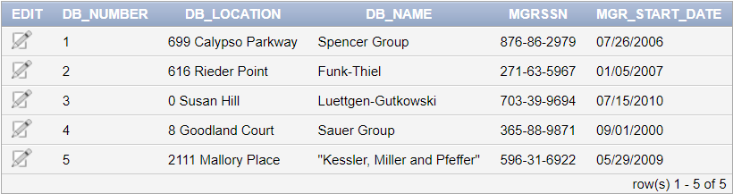

ALTER TABLE EMPLOYEE ADD CONSTRAINT FK_DNUM FOREIGN KEY (DNUM) REFERENCES DEALERSHIP_BRANCH (DB_NUMBER);

CREATE TABLE CLIENT(

SSN CHAR(11) NOT NULL,

EMAIL VARCHAR(40) NOT NULL,

PHONE_NUMBER VARCHAR(30) NOT NULL,

ADDRESS VARCHAR(60) Not NULL,

SEX CHAR(1) CHECK(SEX in ('M','F')) NOT NULL,

DOB Date Not NULL,

FNAME VARCHAR(20) NOT NULL,

MNAME VARCHAR(20) Not NULL,

LNAME VARCHAR(20) NOT NULL,

SEC_COMP_NAME VARCHAR(20),

CONSTRAINT PK_CSSN PRIMARY KEY(SSN)

)

INSERT INTO CLIENT Values('704-18-4532','isauvain2k@indiatimes.com','672-111-7390','9 Grayhawk Plaza','F',DATE'2000-08-17','Karoline','Gunilla','Gale','COM 1');

INSERT INTO CLIENT Values('726-53-5453','amagrane13@buzzfeed.com','382-396-2543','21036 Meadow Ridge Park','M',DATE'2000-07-03','Care','Sherman','Thaddeus','COM 2');

INSERT INTO CLIENT Values('606-23-7587','kblankenship1@cnbc.com','755-517-4319','72025 Amoth Terrace','M',DATE'2000-02-02','Kerry','Faydra','Niles','COM 3');

INSERT INTO CLIENT Values('864-59-4741','lroskelleyo@skype.com','214-762-5304','8 Goodland Court','M',DATE'2000-01-09','Elsworth','Janis','Jeno','COM 4');

INSERT INTO CLIENT Values('118-46-3943','ggurwoodh@comcast.net','149-337-7454','8 Declaration Place','F',DATE '2003-01-15','Selinda','Joelynn','Dulcie','COM 5');

INSERT INTO CLIENT Values('250-93-2795','cmccrisken2n@constantcontact.com','713-500-3571','63991 Bobwhite Street','M',DATE'1999-05-10','Luella','Rudyard','Currie','COM 6');

INSERT INTO CLIENT Values('137-89-2309','bharpur8@soup.io','405-799-2974','8 Goodland Court','M',DATE'1992-05-20','Spense','Flo','Stefano','COM 7');

INSERT INTO CLIENT Values('396-25-9078','bshutler29@census.gov','405-799-2974','3 Granby Point','M',DATE'1997-04-17','Maryellen','Agustin','Sherman','COM 8');

INSERT INTO CLIENT Values('429-71-3391','fbreacherq@i2i.jp','177-936-1775','1 Emmet Way','M',DATE'2002-10-10','Ingrim','Benjy','Saxon','COM 9');

INSERT INTO CLIENT Values('536-37-9870','tstquentin2a@freewebs.com','196-378-8817','0923 Crownhardt Terrace','M',DATE'1998-10-20','Marlane','Emelina','Cynde','COM 10');

INSERT INTO CLIENT Values('425-68-3741','nbratch1g@home.pl','453-781-4279','2 Utah Drive','M',DATE'2000-01-04','Jilli','Luella','Althea','COM 1');

INSERT INTO CLIENT Values('725-62-3915','wmajore@networkadvertising.org','748-944-2193','120 Aberg Junction','M',DATE'1998-10-11','Thaddeus','Cecil','Cully','COM 2');

INSERT INTO CLIENT Values('630-35-1788','kburberryc@spotify.com','748-937-8284','31 Burrows Lane','F',DATE'1992-06-06','Eliot','Neddy','Jerrome','COM 3');

INSERT INTO CLIENT Values('645-88-9596','gjosovitz1a@amazon.de','817-253-7465','7902 Cody Crossing','M',DATE'1993-04-04','Agustin','Cynde','Wenonah','COM 4');

INSERT INTO CLIENT Values('361-81-9054','jiddinsa@infoseek.co.jp','362-660-5747','5 Cherokee Street','F',DATE'1991-03-13','Armstrong','Loella','Laurena','COM 5');

INSERT INTO CLIENT Values('340-16-2894','fbreacherq@i2i.jp','994-132-8197','3 Kensington Hill','M',DATE'2001-04-12','Laurena','Darlleen','Emelina','COM 6');

INSERT INTO CLIENT Values('779-57-5319','hhawksby1i@slate.com','165-841-4616','4338 Autumn Leaf Plaza','F',DATE'1965-08-09','Aloin','Marena','Gill','COM 7');

INSERT INTO CLIENT Values('376-23-9292','wmajore@networkadvertising.org','516-170-9866','15511 Carpenter Point','F',DATE'1990-05-20','Gunilla','Jeno','Agustin','COM 8');

INSERT INTO CLIENT Values('420-30-2048','gkobpa2i@privacy.gov.au','432-617-7274','5 Lillian Point','M',DATE'1991-05-02','Neddy','Dario','Sheilakathryn','COM 9');

INSERT INTO CLIENT Values('240-68-6986','swestoff1w@rambler.ru','994-132-8197','8167 Hudson Court','M',DATE'1982-07-06','Angie','Celeste','Rudyard','COM 10');

​

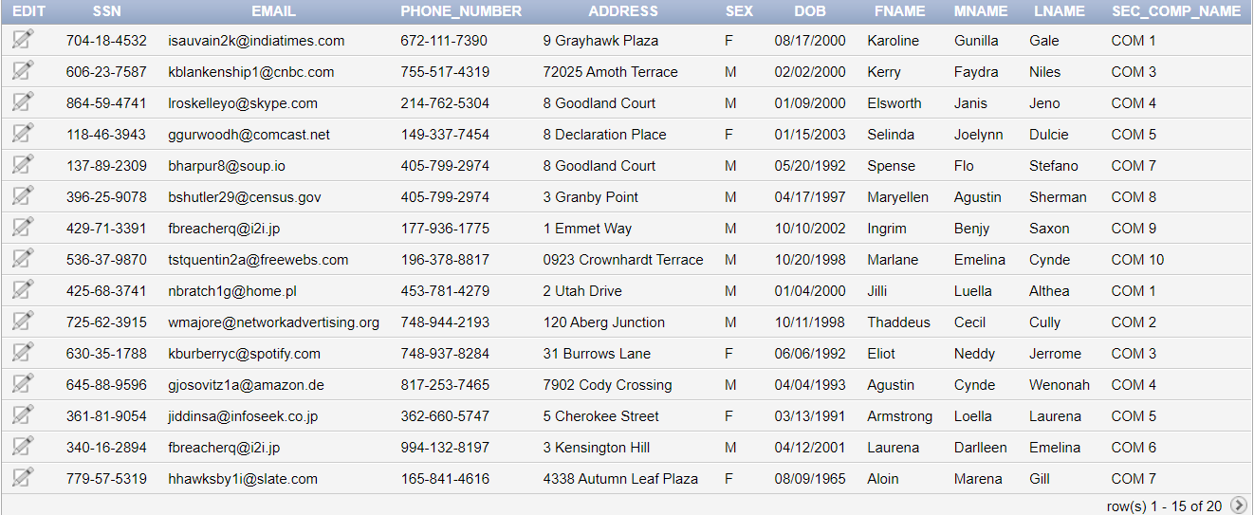

CREATE TABLE SECURITY_COMPANY

(

SEC_C_NAME VARCHAR(20) NOT NULL,

SEC_C_EMAIL VARCHAR(50),

SEC_C_PHONE_NUMBER VARCHAR(20) NOT NULL,

SECURITY_SPECILIZATION VARCHAR (20) NOT NULL,

CONSTRAINT PK_SEC_NAME PRIMARY KEY (SEC_C_NAME)

)

INSERT INTO SECURITY_COMPANY Values('COM 1','tstquentin2a@freewebs.com','432-617-7274','Class D');

INSERT INTO SECURITY_COMPANY Values('COM 2','kburberryc@spotify.com','758-347-2687','Class E');

INSERT INTO SECURITY_COMPANY Values('COM 3','pmontelr@alexa.com','769-338-5999','Class D');

INSERT INTO SECURITY_COMPANY Values('COM 4','nbratch1g@home.pl','346-944-1354','Class B');

INSERT INTO SECURITY_COMPANY Values('COM 5','lwernher23@reference.com','775-933-3437','Class E');

INSERT INTO SECURITY_COMPANY Values('COM 6','psharpinj@walmart.com','281-626-8254','Class E');

INSERT INTO SECURITY_COMPANY Values('COM 7','ckuhndel1c@printfriendly.com','196-378-8817','Class E');

INSERT INTO SECURITY_COMPANY Values('COM 8','afores2p@wikipedia.org','242-926-2020','Class C');

INSERT INTO SECURITY_COMPANY Values('COM 9','uisabell2e@craigslist.org','907-248-1609','Class B');

INSERT INTO SECURITY_COMPANY Values('COM 10','jkunes1f@google.com.au','572-472-5390','Class E');

Alter Table CLIENT ADD CONSTRAINT FK_SCN FOREIGN KEY (Sec_Comp_Name ) REFERENCES SECURITY_COMPANY (SEC_C_NAME );

​

CREATE TABLE CONTRACT(

Contract_ID INTEGER NOT NULL,

Start_Date DATE NOT NULL,

End_Date Date NOT NULL,

Payment_Method VARCHAR(20) NOT NULL,

Total_Payment INTEGER NOT NULL,

DNUM INTEGER NOT NULL,

CONSTRAINT PK_Contract_ID PRIMARY KEY(Contract_ID),

CONSTRAINT FK_DNUM_CONTRACT FOREIGN KEY (DNUM) REFERENCES DEALERSHIP_BRANCH(DB_NUMBER)

)

INSERT INTO CONTRACT Values(32,DATE'2022-01-23',DATE'2023-11-23','Cash',3720,1);

INSERT INTO CONTRACT Values(38797,DATE'2022-11-28',DATE'2023-7-03', Crypto Currency,4087,1);

INSERT INTO CONTRACT Values(5203,DATE'2022-08-28',DATE'2022-10-06','Bank Transfer',2248,1);

INSERT INTO CONTRACT Values(8,DATE'2022-07-19',DATE'2023-06-18', Crypto Currency,2182,1);

INSERT INTO CONTRACT Values(47265,DATE'2022-07-05',DATE'2023-07-03',Cash,2396,2);

INSERT INTO CONTRACT Values(63,DATE'2022-12-02',DATE'2023-09-27','Visa',7669,2);

INSERT INTO CONTRACT Values(58840,DATE'2022-05-29',DATE'2023-01-05', Crypto Currency,7829,2);

INSERT INTO CONTRACT Values(86,DATE'2022-06-20',DATE'2023-02-08','Visa',8631,2);

INSERT INTO CONTRACT Values(6078,DATE'2022-08-06',DATE'2022-10-12','Visa',6440,3);

INSERT INTO CONTRACT Values(44,DATE'2022-11-23',DATE'2023-02-08','Visa,7669,3);

INSERT INTO CONTRACT Values(6787,DATE'2022-03-31',DATE'2022-08-28','Bank Transfer',3148,3);

INSERT INTO CONTRACT Values(626,DATE'2022-03-08',DATE'2022-08-21','Cash',1361,3);

INSERT INTO CONTRACT Values(564,DATE'2022-10-30',DATE'2023-09-06',' Crypto Currency',3854,4);

INSERT INTO CONTRACT Values(85867,DATE'2022-05-16',DATE'2022-11-25','Visa,7645,4);

INSERT INTO CONTRACT Values(64,DATE'2022-03-23',DATE'2023-09-27','Visa',1104,4);

INSERT INTO CONTRACT Values(76,DATE'2022-09-08',DATE'2023-07-20','Bank Transfer',3179,4);

INSERT INTO CONTRACT Values(665,DATE'2022-10-27',DATE'2023-06-17','Cash',1611,5);

INSERT INTO CONTRACT Values(9266,DATE'2022-08-17',DATE'2023-05-14','Cash,6440,5);

INSERT INTO CONTRACT Values(708,DATE'2022-12-02',DATE'2023-11-25','Visa',2386,5);

INSERT INTO CONTRACT Values(939,DATE'2022-10-30',DATE'2022-11-28', Crypto Currency,2262,5);

​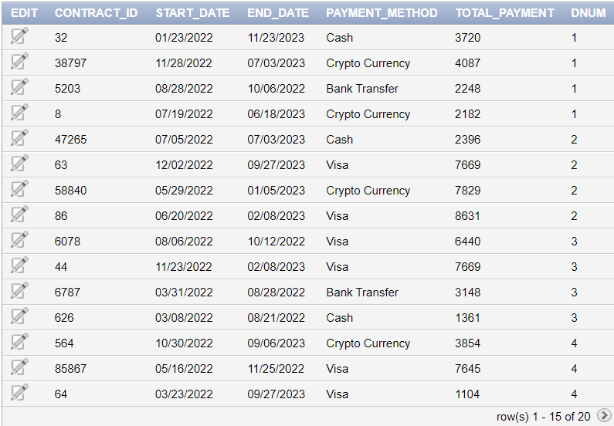

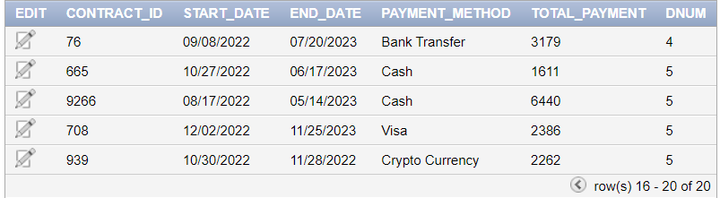

CREATE TABLE INSURANCE_POLICY

(

INSURANCE_ID CHAR(10) NOT NULL,

INSURANCE_CLASS VARCHAR(20) NOT NULL,

COVERED_PERCENTAGE INTEGER NOT NULL,

CONSTRAINT PK_INSURANCE_ID PRIMARY KEY (INSURANCE_ID)

)

INSERT INTO INSURANCE_POLICY Values(7825472659,'B',35);

INSERT INTO INSURANCE_POLICY Values(8435255190,'B',44);

INSERT INTO INSURANCE_POLICY Values(9641953796,'A',74);

INSERT INTO INSURANCE_POLICY Values(1771408170,'B',20);

INSERT INTO INSURANCE_POLICY Values(5261479940,'A',42);

INSERT INTO INSURANCE_POLICY Values(5312112194,'A',34);

INSERT INTO INSURANCE_POLICY Values(6653936139,'B',41);

INSERT INTO INSURANCE_POLICY Values(6764615780,'B',22);

INSERT INTO INSURANCE_POLICY Values(3230230647,'B',40);

INSERT INTO INSURANCE_POLICY Values(8326770752,'A',98);

INSERT INTO INSURANCE_POLICY Values(3645650091,'B',6);

INSERT INTO INSURANCE_POLICY Values(7444388652,'A',94);

INSERT INTO INSURANCE_POLICY Values(4578910725,'A',97);

INSERT INTO INSURANCE_POLICY Values(6147447459,'A',86);

INSERT INTO INSURANCE_POLICY Values(2606944666,'B',94);

INSERT INTO INSURANCE_POLICY Values(3442374987,'B',70);

INSERT INTO INSURANCE_POLICY Values(6785527430,'A',25);

INSERT INTO INSURANCE_POLICY Values(5115695936,'B',33);

INSERT INTO INSURANCE_POLICY Values(8513487848,'A',49);

INSERT INTO INSURANCE_POLICY Values(1855297426,'A',34);​

CREATE TABLE MAINTENANCE_COMPANY

(

COMPANY_NAME VARCHAR(20) NOT NULL,

EMAIL VARCHAR(30),

PHONE_NUMBER VARCHAR(20),

ADDRESS VARCHAR(30),

MAINTENANCE_TYPE VARCHAR(15) NOT NULL,

CONSTRAINT PK_CNAME PRIMARY KEY (COMPANY_NAME)

)

INSERT INTO MAINTENANCE_COMPANY Values('Maintenance 1','pmontelr@alexa.com','264-260-7320','24 Lukken Court','Class B');

INSERT INTO MAINTENANCE_COMPANY Values('Maintenance 2','rdeeks27@slideshare.net','748-944-2193','9 Linden Avenue','Class B');

INSERT INTO MAINTENANCE_COMPANY Values('Maintenance 3','rdeeks27@slideshare.net','468-220-8498','52 Sage Parkway','Class E');

INSERT INTO MAINTENANCE_COMPANY Values('Maintenance 4','uyter1v@blog.com','281-626-8254','153 Muir Park','Class D');

INSERT INTO MAINTENANCE_COMPANY Values('Maintenance 5','kberkowitz18@businesswire.com','264-260-7320','63991 Bobwhite Street','Class D');

INSERT INTO MAINTENANCE_COMPANY Values('Maintenance 6','kburberryc@spotify.com','246-929-8951','15511 Carpenter Point','Class E');

INSERT INTO MAINTENANCE_COMPANY Values('Maintenance 7','swestoff1w@rambler.ru','177-936-1775','5 Laurel Court','Class B');

INSERT INTO MAINTENANCE_COMPANY Values('Maintenance 8','kblankenship1@cnbc.com','553-674-0222','428 Granby Junction','Class B');

INSERT INTO MAINTENANCE_COMPANY Values('Maintenance 9','kslack10@symantec.com','480-112-3970','1 Emmet Way','Class B');

INSERT INTO MAINTENANCE_COMPANY Values('Maintenance 10','hcraw4@paypal.com','207-713-6547','7 Hagan Court','Class D');

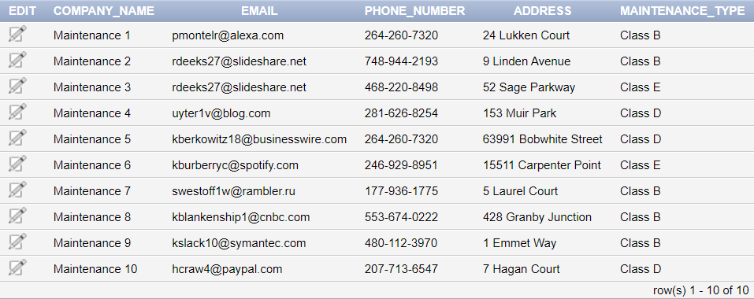​

CREATE TABLE CLEANING_COMPANY

(

CLC_COMPANY_NAME VARCHAR(40) NOT NULL,

CLC_EMAIL VARCHAR(40) NOT NULL,

CLC_PHONE_NUMBER VARCHAR(15) NOT NULL,

CLC_ADDRESS VARCHAR(50),

CLC_SERVICE_TYPE VARCHAR(30) NOT NULL,

CONSTRAINT PK_CLC_COMPANY_NAME PRIMARY KEY (CLC_COMPANY_NAME)

)

INSERT INTO CLEANING_COMPANY Values('"Kuphal, Metz and Walsh"','tyaldren1e@squarespace.com','453-781-4279','69 Burning Wood Drive','Deep Cleaning');

INSERT INTO CLEANING_COMPANY Values('Crist-Okuneva','mhubery26@studiopress.com','671-821-8634','153 Muir Park','Hand Car Wash');

INSERT INTO CLEANING_COMPANY Values('Dickens Group','hdevaan24@com.com','671-821-8634','9 Linden Avenue','Deep Cleaning');

INSERT INTO CLEANING_COMPANY Values('Corwin-Jacobi','gkobpa2i@privacy.gov.au','885-663-6757','260 Anhalt Circle','Soft Touch Car Washes');

INSERT INTO CLEANING_COMPANY Values('Marvin, Beatty and Howe','tnoddle1k@umich.edu','264-260-7320','616 Rieder Point','Interior Detailing');

INSERT INTO CLEANING_COMPANY Values('Leffler-Lehner','scamplejohnk@barnesandnoble.com','319-836-3016','52918 Oriole Circle','Waterless Mobile Car Wash');

INSERT INTO CLEANING_COMPANY Values('Collier Inc','hhawksby1i@slate.com','182-511-6033','202 Derek Center','Complete Interior Detailing');

INSERT INTO CLEANING_COMPANY Values('OKeefe-Blick','crodolfi2r@aol.com','938-144-3985','2 Brickson Park Drive','Full Exterior Detailing');

INSERT INTO CLEANING_COMPANY Values('Lubowitz, Bruen and Toy’,'kmacconchie2b@mit.edu','617-692-4729','07 Boyd Park','Full Detailing');

INSERT INTO CLEANING_COMPANY Values('Wunsch, Wilderman and Harber','nbratch1g@home.pl','942-825-4634','36 Cascade Avenue','Deep Cleaning');​

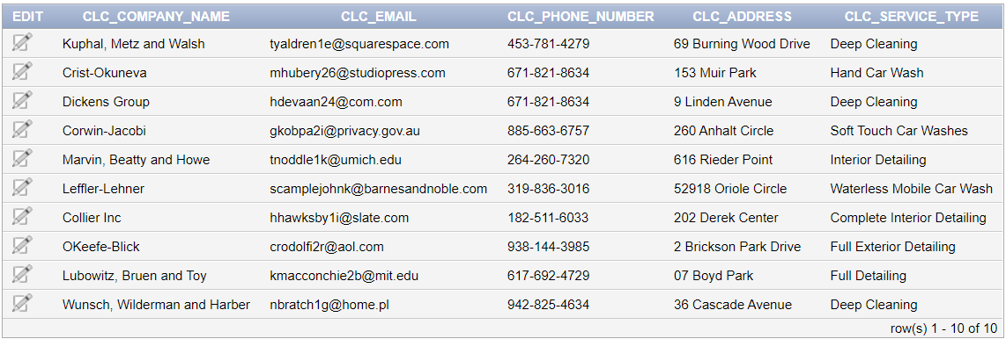

CREATE TABLE CAR

(

VIN CHAR(17) NOT NULL,

STATE CHAR(3) NOT NULL,

LNUMBER INTEGER NOT NULL,

YEAROFPRODUCTION DATE NOT NULL,

TYPE VARCHAR(15),

MILEAGE FLOAT(2) NOT NULL,

INS_ID CHAR(10) NOT NULL,

CC_NAME VARCHAR(40) NOT NULL,

CONSTRAINT PK_VIN PRIMARY KEY (VIN),

CONSTRAINT FKINS_ID FOREIGN KEY (INS_ID) REFERENCES INSURANCE_POLICY(INSURANCE_ID ) ,

CONSTRAINT FKCC_NAME FOREIGN KEY(CC_NAME) REFERENCES CLEANING_COMPANY (CLC_COMPANY_NAME)

)

INSERT INTO CAR Values('1G6DM5E38C0458799','SAI',12,DATE'2010-05-20','Ford','55874.37',7825472659,'"Kuphal, Metz and Walsh"');

INSERT INTO CAR Values('1N6AD0CU6EN387958','QUR',24,DATE'2015-08-08','Mercedes-Benz','72364.19',8435255190,'Crist-Okuneva');

INSERT INTO CAR Values('1GKKRNEDXCJ663313','Los',1,DATE'2022-08-08','Mercedes-Benz','73029.46',9641953796,'Dickens Group');

INSERT INTO CAR Values('WAUKF78E88A666669','O',23,DATE'2021-02-20','Nissan','16246.82',1771408170,'Corwin-Jacobi');

INSERT INTO CAR Values('WA1CKBFP8AA978999','SAI',30,DATE'2009-06-10','Chevrolet','70208.27',5261479940,'"Marvin, Beatty and Howe"');

INSERT INTO CAR Values('1FTWF3C57AE349711','QUR',1,DATE'2016-10-15','GMC','59227.42',5312112194,'Leffler-Lehner');

INSERT INTO CAR Values('4A4AP3AU1EE948395','Los',25,DATE'2013-02-15','Ford','10526.78',6653936139,'Collier Inc');

INSERT INTO CAR Values('2C4RRGAG8DR694692','Los',7,DATE'2011-08-10','Ford','77093.35',6764615780,'OKeefe-Blick');

INSERT INTO CAR Values('WA1MYBFE5AD954370','SBH',7,DATE'2015-12-13','Mazda','70805.9',3230230647,'"Lubowitz, Bruen and Toy"');

INSERT INTO CAR Values('WBSBL93491J729007','Los',5,DATE'2009-07-14','Saturn','13849.6',8326770752,'"Dickens, Thompson and Gislason"');

INSERT INTO CAR Values('1FADP5AU3FL707229','SAI',1,DATE'2009-12-15','Mercury','82152.07',3645650091,'Wolf-Waters');

INSERT INTO CAR Values('3LN6L2LU1FR554065','NEW',3,DATE'2014-12-16','Lincoln','44889.63',7444388652,'Borer and Sons');

INSERT INTO CAR Values('WVWAN7AN0DE341691','NEW',6,DATE'2017-02-20','Chevrolet','60051.62',4578910725,'Wintheiser-Leuschke');

INSERT INTO CAR Values('WBAPN7C53BF335699','Los',26,DATE'2021-05-21','Lincoln','93021.3',6147447459,'Jaskolski Inc');

INSERT INTO CAR Values('1GYS3FEJ5BR908845','EST',25,DATE'2012-01-29','Mercury','12936.28',2606944666,'Rogahn-Zemlak');

INSERT INTO CAR Values('WDDNG7BB8AA766259','TX',26,DATE'2010-02-27','Nissan','19208.29',3442374987,'"Keeling, Schmitt and Marks"');

INSERT INTO CAR Values('WBAAX13485P075819','SBH',21,DATE'2022-11-26','Dodge','32016.35',6785527430,'"Thompson, Wilkinson and Glover"');

INSERT INTO CAR Values('JN1AZ4EH9FM988125','EST',19,DATE'2012-05-21','Kia','82152.07',5115695936,'Robel Group');

INSERT INTO CAR Values('WA1AV74LX7D425256','SBH',10,DATE'2013-10-08','Buick','44889.63',8513487848,'Torphy Group');

INSERT INTO CAR Values('1C6RD6GP7CS412806','EST',5,DATE'2022-03-07','Chevrolet','46169.17',1855297426,'"Wunsch, Wilderman and Harber"');

​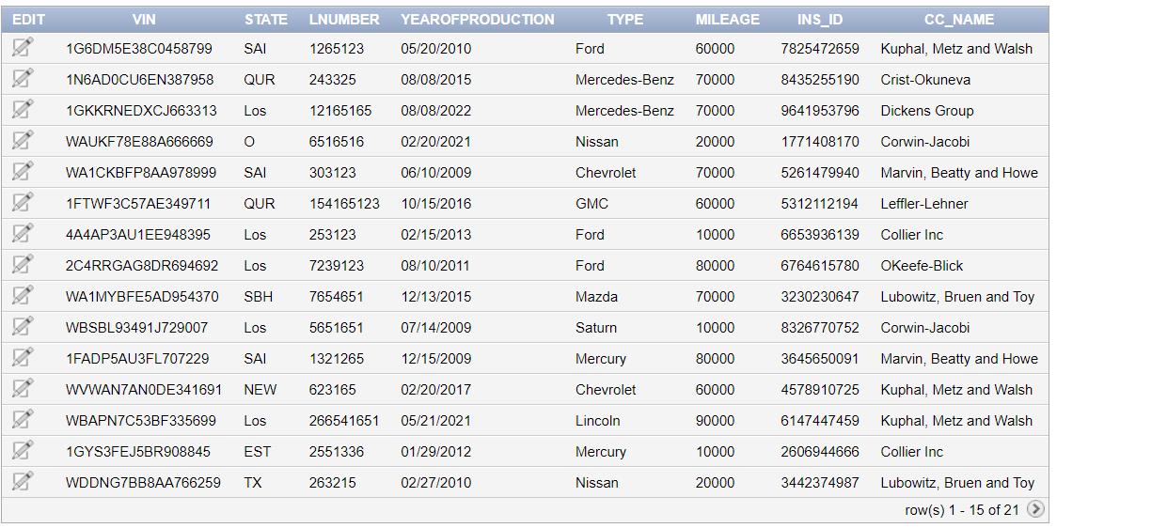

CREATE TABLE SHIPPING_COMPANY

(

SHP_NAME VARCHAR(20) NOT NULL,

SHP_EMAIL VARCHAR(50) NOT NULL,

SHP_PHONE_NUMBER VARCHAR(12) NOT NULL,

SHP_ADDRESS VARCHAR(50),

CONSTRAINT PK_SHP_NAME PRIMARY KEY (SHP_NAME)

)

INSERT INTO SHIPPING_COMPANY Values('Shipping 1','gjosovitz1a@amazon.de','500-625-3883','41135 Ridgeway Road');

INSERT INTO SHIPPING_COMPANY Values('Shipping 2','jiddinsa@infoseek.co.jp','955-118-6190','5 Laurel Court');

INSERT INTO SHIPPING_COMPANY Values('Shipping 3','rterrans1m@miibeian.gov.cn','242-926-2020','29106 Doe Crossing Hill');

INSERT INTO SHIPPING_COMPANY Values('Shipping 4','swoodcock0@dropbox.com','769-338-5999','3 Hudson Drive');

INSERT INTO SHIPPING_COMPANY Values('Shipping 5','sfredi28@paginegialle.it','994-132-8197','1 Emmet Way');

INSERT INTO SHIPPING_COMPANY Values('Shipping 6','cknight2@smh.com.au','560-414-2660','3 Hudson Drive');

INSERT INTO SHIPPING_COMPANY Values('Shipping 7','lwernher23@reference.com','874-728-8251','8 Oriole Park');

INSERT INTO SHIPPING_COMPANY Values('Shipping 8','dislandm@tuttocitta.it','842-816-2201','575 Westend Road');

INSERT INTO SHIPPING_COMPANY Values('Shipping 9','jwoolens25@apple.com','207-713-6547','366 Shasta Road');

INSERT INTO SHIPPING_COMPANY Values('Shipping 10','psharpinj@walmart.com','150-492-0297','4072 Mendota Hill');

INSERT INTO SHIPPING_COMPANY Values('Shipping 11','gjosovitz1a@amazon.de','874-728-8251','54 Rieder Junction');

INSERT INTO SHIPPING_COMPANY Values('Shipping 12','lwernher23@reference.com','907-248-1609','29106 Doe Crossing Hill');

INSERT INTO SHIPPING_COMPANY Values('Shipping 13','lwernher23@reference.com','496-568-8900','4338 Autumn Leaf Plaza');

INSERT INTO SHIPPING_COMPANY Values('Shipping 14','wfoote1p@gravatar.com','504-408-0609','55459 Sage Street');

INSERT INTO SHIPPING_COMPANY Values('Shipping 15','rbinding1o@last.fm','289-429-6028','0203 West Alley');

INSERT INTO SHIPPING_COMPANY Values('Shipping 16','jaulton7@webs.com','933-286-4532','753 Evergreen Circle');

INSERT INTO SHIPPING_COMPANY Values('Shipping 17','mmcneil2f@360.cn','577-423-8148','29106 Doe Crossing Hill');

INSERT INTO SHIPPING_COMPANY Values('Shipping 18','mmcneil2f@360.cn','666-890-1929','798 Autumn Leaf Road');

INSERT INTO SHIPPING_COMPANY Values('Shipping 19','rterrans1m@miibeian.gov.cn','335-296-8558','51232 Moland Plaza');

INSERT INTO SHIPPING_COMPANY Values('Shipping 20','pfindlaterp@bbc.co.uk','362-660-5747','03 Homewood Junction');​

CREATE TABLE SUPPLIER

( SUP_NAME VARCHAR(20) NOT NULL,

SUP_EMAIL VARCHAR(50),

SUP_PHONE_NUMBER VARCHAR(12) NOT NULL,

SUP_ADDRESS VARCHAR(50),

VIN CHAR(17) NOT NULL,

STATE CHAR(3) NOT NULL,

LNUMBER INTEGER NOT NULL,

CONSTRAINT PK_SUP_NAME PRIMARY KEY (SUP_NAME),

CONSTRAINT FK_VIN FOREIGN KEY(VIN) REFERENCES CAR(VIN)

)

INSERT INTO Supplier Values('Supplier 1','pmontelr@alexa.com','938-144-3985','2111 Mallory Place','1G6DM5E38C0458799','NEW',7);

INSERT INTO Supplier Values('Supplier 2','mmcneil2f@360.cn','458-703-3124','89 Caliangt Hill','1N6AD0CU6EN387958','SBH',12);

INSERT INTO Supplier Values('Supplier 3','mthurgoodi@utexas.edu','912-294-2898','4072 Mendota Hill','1GKKRNEDXCJ663313','TX',25);

INSERT INTO Supplier Values('Supplier 4','cedsell1q@imageshack.us','496-568-8900','04219 Moulton Circle','WAUKF78E88A666669','NEW',9);

INSERT INTO Supplier Values('Supplier 5','wmajore@networkadvertising.org','755-517-4319','3062 Texas Way','WA1CKBFP8AA978999','NEW',29);

INSERT INTO Supplier Values('Supplier 6','dislandm@tuttocitta.it','907-248-1609','72025 Amoth Terrace','1FTWF3C57AE349711','TAX',27);

INSERT INTO Supplier Values('Supplier 7','scamplejohnk@barnesandnoble.com','382-396-2543','67 Spaight Pass','4A4AP3AU1EE948395','SBH',22);

INSERT INTO Supplier Values('Supplier 8','fbreacherq@i2i.jp','854-268-8350','9 Victoria Center','2C4RRGAG8DR694692','SAI',22);

INSERT INTO Supplier Values('Supplier 9','hcraw4@paypal.com','755-517-4319','3 Randy Avenue','WA1MYBFE5AD954370','QUR',11);

INSERT INTO Supplier Values('Supplier 10','vgiraudeau1h@discovery.com','516-170-9866','69 Burning Wood Drive','WBSBL93491J729007','Los',16);

INSERT INTO Supplier Values('Supplier 11','amea1s@aol.com','246-929-8951','616 Rieder Point','1FADP5AU3FL707229','Los',29);

INSERT INTO Supplier Values('Supplier 12','isauvain2k@indiatimes.com','103-105-9454','8167 Hudson Court','3LN6L2LU1FR554065','O',5);

INSERT INTO Supplier Values('Supplier 13','dmegainey20@free.fr','612-299-0051','120 Aberg Junction','WVWAN7AN0DE341691','EST',9);

INSERT INTO Supplier Values('Supplier 14','jmetcalf2o@shop-pro.jp','617-692-4729','753 Evergreen Circle','WBAPN7C53BF335699','QUR',19);

INSERT INTO Supplier Values('Supplier 15','scamplejohnk@barnesandnoble.com','165-841-4616','8 Goodland Court','1GYS3FEJ5BR908845','SBH',29);

INSERT INTO Supplier Values('Supplier 16','mhubery26@studiopress.com','149-337-7454','8 Ridgeway Lane','WDDNG7BB8AA766259','QUR',4);

INSERT INTO Supplier Values('Supplier 17','fbigrigg2m@is.gd','450-129-3968','29106 Doe Crossing Hill','WBAAX13485P075819','NEW',9);

INSERT INTO Supplier Values('Supplier 18','gkobpa2i@privacy.gov.au','468-985-9871','36 Cascade Avenue','JN1AZ4EH9FM988125','EST',29);

INSERT INTO Supplier Values('Supplier 19','omorforthy@naver.com','854-268-8350','8 Oriole Park','WA1AV74LX7D425256','EST',3);

INSERT INTO Supplier Values('Supplier 20','mmcneil2f@360.cn','405-799-2974','0203 West Alley','1C6RD6GP7CS412806','SBH',8);​

CREATE TABLE DEPENDENT (

ESSN CHAR(11) NOT NULL,

Name VARCHAR(20) NOT NULL,

Relationship VARCHAR(20) NOT NULL,

E_SEX CHAR(1) CHECK( E_SEX in ('M','F')) NOT NULL,

Date_Of_Birth Date NOT NULL,

CONSTRAINT PK_ESSN_Name PRIMARY KEY (ESSN,Name),

CONSTRAINT FK_ESSN FOREIGN KEY (ESSN) REFERENCES EMPLOYEE (E_SSN)

)

INSERT INTO DEPENDENT Values('876-86-2979','Celeste','Sibling','F',DATE'2004-08-08');

INSERT INTO DEPENDENT Values('271-63-5967','Merell','Brother','M',DATE'2005-01-01');

INSERT INTO DEPENDENT Values('703-39-9694','Thane','Wife','M',DATE'1980-05-05');

INSERT INTO DEPENDENT Values('365-88-9871','Maryellen','Sibling','M',DATE'2004-01-06');

INSERT INTO DEPENDENT Values('596-31-6922','Flo','Sibling','F',DATE'1999-04-05');

INSERT INTO DEPENDENT Values('523-18-6661','Odilia','Mother','M',DATE'1970-12-19');

INSERT INTO DEPENDENT Values('429-46-7711','Merell','Child','M',DATE'2015-08-08');

INSERT INTO DEPENDENT Values('537-78-6694','Darleen','Child','M',DATE'2016-05-08');

INSERT INTO DEPENDENT Values('181-42-7396','Sibelle','Brother','M',DATE'1999-12-13');

INSERT INTO DEPENDENT Values('404-20-0225','Spense','Sibling','M',DATE'1999-01-15');

INSERT INTO DEPENDENT Values('762-57-7792','Aguistin','Mother','M',DATE'1965-12-13');

INSERT INTO DEPENDENT Values('282-74-5136','Giacobo','Sibling','M',DATE'2008-09-01');

INSERT INTO DEPENDENT Values('384-99-8649','Agustin','Mother','F',DATE'1977-07-07');

INSERT INTO DEPENDENT Values('617-54-8955','Dael','Wife','M',DATE'1980-04-01');

INSERT INTO DEPENDENT Values('235-27-7224','Elsworth','Wife','F',DATE'1999-12-09');

INSERT INTO DEPENDENT Values('290-75-7924','Aloin','Child','M',DATE'2020-10-15');

INSERT INTO DEPENDENT Values('747-72-2546','Joelynn','Mother','F',DATE'1965-11-12');

INSERT INTO DEPENDENT Values('658-78-5009','Wiley','Mother','F',DATE'1960-02-05');

INSERT INTO DEPENDENT Values('610-63-9600','Wiley','Brother','M',DATE'1999-11-06');

INSERT INTO DEPENDENT Values('819-75-3652','Jerrome','Child','M',DATE'2018-03-02');​

CREATE TABLE Is_Maintained_By(

Company_Name VARCHAR(20) NOT NULL,

VIN CHAR(17) NOT NULL,

CONSTRAINT PK_ALL PRIMARY KEY (Company_Name, VIN),

CONSTRAINT FK_Company_Name FOREIGN KEY (Company_Name) REFERENCES MAINTENANCE_COMPANY(COMPANY_NAME) ,

CONSTRAINT FK_Car FOREIGN KEY(VIN) REFERENCES CAR(VIN)

)

INSERT INTO Is_Maintained_By Values('Maintenance 1','1G6DM5E38C0458799');

INSERT INTO Is_Maintained_By Values('Maintenance 1','1N6AD0CU6EN387958');

INSERT INTO Is_Maintained_By Values('Maintenance 1','1GKKRNEDXCJ663313');

INSERT INTO Is_Maintained_By Values('Maintenance 2','WAUKF78E88A666669');

INSERT INTO Is_Maintained_By Values('Maintenance 2','WA1CKBFP8AA978999');

INSERT INTO Is_Maintained_By Values('Maintenance 2','1FTWF3C57AE349711');

INSERT INTO Is_Maintained_By Values('Maintenance 3','4A4AP3AU1EE948395');

INSERT INTO Is_Maintained_By Values('Maintenance 3','2C4RRGAG8DR694692');

INSERT INTO Is_Maintained_By Values('Maintenance 4','WA1MYBFE5AD954370');

INSERT INTO Is_Maintained_By Values('Maintenance 4','WBSBL93491J729007');

INSERT INTO Is_Maintained_By Values('Maintenance 5','1FADP5AU3FL707229');

INSERT INTO Is_Maintained_By Values('Maintenance 5','3LN6L2LU1FR554065');

INSERT INTO Is_Maintained_By Values('Maintenance 6','WVWAN7AN0DE341691');

INSERT INTO Is_Maintained_By Values('Maintenance 6','WBAPN7C53BF335699');

INSERT INTO Is_Maintained_By Values('Maintenance 7','1GYS3FEJ5BR908845');

INSERT INTO Is_Maintained_By Values('Maintenance 7','WDDNG7BB8AA766259');

INSERT INTO Is_Maintained_By Values('Maintenance 8','WBAAX13485P075819');

INSERT INTO Is_Maintained_By Values('Maintenance 8','JN1AZ4EH9FM988125');

INSERT INTO Is_Maintained_By Values('Maintenance 9','WA1AV74LX7D425256');

INSERT INTO Is_Maintained_By Values('Maintenance 9','1C6RD6GP7CS412806');​

CREATE TABLE IDENTIFIES

(

CONT_ID INTEGER NOT NULL,

CVIN CHAR(17) NOT NULL,

CONSTRAINT PK_IDENTIFIES PRIMARY KEY(CONT_ID,CVIN),

CONSTRAINT FK_CID FOREIGN KEY(CONT_ID) REFERENCES CONTRACT (CONTRACT_ID) ,

CONSTRAINT FK_CVIN FOREIGN KEY(CVIN) REFERENCES CAR(VIN)

)

INSERT INTO IDENTIFIES Values(32,'1G6DM5E38C0458799');

INSERT INTO IDENTIFIES Values(38797,'1N6AD0CU6EN387958');

INSERT INTO IDENTIFIES Values(5203,'1GKKRNEDXCJ663313');

INSERT INTO IDENTIFIES Values(8,'WAUKF78E88A666669');

INSERT INTO IDENTIFIES Values(47265,'WA1CKBFP8AA978999');

INSERT INTO IDENTIFIES Values(63,'1FTWF3C57AE349711');

INSERT INTO IDENTIFIES Values(58840,'4A4AP3AU1EE948395');

INSERT INTO IDENTIFIES Values(86,'2C4RRGAG8DR694692');

INSERT INTO IDENTIFIES Values(6078,'WA1MYBFE5AD954370');

INSERT INTO IDENTIFIES Values(44,'WBSBL93491J729007');

INSERT INTO IDENTIFIES Values(6787,'1FADP5AU3FL707229');

INSERT INTO IDENTIFIES Values(626,'3LN6L2LU1FR554065');

INSERT INTO IDENTIFIES Values(564,'WVWAN7AN0DE341691');

INSERT INTO IDENTIFIES Values(85867,'WBAPN7C53BF335699');

INSERT INTO IDENTIFIES Values(64,'1GYS3FEJ5BR908845');

INSERT INTO IDENTIFIES Values(76,'WDDNG7BB8AA766259');

INSERT INTO IDENTIFIES Values(665,'WBAAX13485P075819');

INSERT INTO IDENTIFIES Values(9266,'JN1AZ4EH9FM988125');

INSERT INTO IDENTIFIES Values(708,'WA1AV74LX7D425256');

INSERT INTO IDENTIFIES Values(939,'1C6RD6GP7CS412806');​

CREATE TABLE SHIPPED_BY

(

SCOM_NAME VARCHAR(20) NOT NULL,

SVIN CHAR(17) NOT NULL,

CONSTRAINT PK_SHIPPED_BY PRIMARY KEY(SCOM_NAME,SVIN),

CONSTRAINT PKSNAME FOREIGN KEY (SCOM_NAME) REFERENCES SHIPPING_COMPANY(SHP_NAME) ,

CONSTRAINT FKSVIN FOREIGN KEY (SVIN) REFERENCES CAR(VIN)

)

INSERT INTO SHIPPED_BY Values('Shipping 1','1G6DM5E38C0458799');

INSERT INTO SHIPPED_BY Values('Shipping 2','1N6AD0CU6EN387958');

INSERT INTO SHIPPED_BY Values('Shipping 3','1GKKRNEDXCJ663313');

INSERT INTO SHIPPED_BY Values('Shipping 4','WAUKF78E88A666669');

INSERT INTO SHIPPED_BY Values('Shipping 5','WA1CKBFP8AA978999');

INSERT INTO SHIPPED_BY Values('Shipping 6','1FTWF3C57AE349711');

INSERT INTO SHIPPED_BY Values('Shipping 7','4A4AP3AU1EE948395');

INSERT INTO SHIPPED_BY Values('Shipping 8','2C4RRGAG8DR694692');

INSERT INTO SHIPPED_BY Values('Shipping 9','WA1MYBFE5AD954370');

INSERT INTO SHIPPED_BY Values('Shipping 10','WBSBL93491J729007');

INSERT INTO SHIPPED_BY Values('Shipping 11','1FADP5AU3FL707229');

INSERT INTO SHIPPED_BY Values('Shipping 12','3LN6L2LU1FR554065');

INSERT INTO SHIPPED_BY Values('Shipping 13','WVWAN7AN0DE341691');

INSERT INTO SHIPPED_BY Values('Shipping 14','WBAPN7C53BF335699');

INSERT INTO SHIPPED_BY Values('Shipping 15','1GYS3FEJ5BR908845');

INSERT INTO SHIPPED_BY Values('Shipping 16','WDDNG7BB8AA766259');

INSERT INTO SHIPPED_BY Values('Shipping 17','WBAAX13485P075819');

INSERT INTO SHIPPED_BY Values('Shipping 18','JN1AZ4EH9FM988125');

INSERT INTO SHIPPED_BY Values('Shipping 19','WA1AV74LX7D425256');

INSERT INTO SHIPPED_BY Values('Shipping 20','1C6RD6GP7CS412806');​

CREATE TABLE SIGNS

(

CSSN CHAR(11) NOT NULL,

CONTRA_ID INTEGER NOT NULL,

DIS_vALUE INTEGER,

CONSTRAINT PK_SIGNS PRIMARY KEY(CSSN,CONTRA_ID),

CONSTRAINT FKC_ID FOREIGN KEY (CONTRA_ID) REFERENCES CONTRACT (Contract_ID) ,

CONSTRAINT FKCSSN FOREIGN KEY (CSSN) REFERENCES CLIENT(SSN)

)

INSERT INTO Signs Values('704-18-4532',32,35);

INSERT INTO Signs Values('726-53-5453',38797,44);

INSERT INTO Signs Values('606-23-7587',5203,74);

INSERT INTO Signs Values('864-59-4741',8,20);

INSERT INTO Signs Values('118-46-3943',47265,42);

INSERT INTO Signs Values('250-93-2795',63,34);

INSERT INTO Signs Values('137-89-2309',58840,41);

INSERT INTO Signs Values('396-25-9078',86,22);

INSERT INTO Signs Values('429-71-3391',6078,40);

INSERT INTO Signs Values('536-37-9870',44,98);

INSERT INTO Signs Values('425-68-3741',6787,6);

INSERT INTO Signs Values('725-62-3915',626,94);

INSERT INTO Signs Values('630-35-1788',564,97);

INSERT INTO Signs Values('645-88-9596',85867,86);

INSERT INTO Signs Values('361-81-9054',64,94);

INSERT INTO Signs Values('340-16-2894',76,70);

INSERT INTO Signs Values('779-57-5319',665,25);

INSERT INTO Signs Values('376-23-9292',9266,33);

INSERT INTO Signs Values('420-30-2048',708,49);

INSERT INTO Signs Values('240-68-6986',939,34);​

CREATE TABLE HIRES(

SCNAME VARCHAR(20) NOT NULL,

DNUM INTEGER NOT NULL,

CONSTRAINT PK_ALL_Hires PRIMARY KEY(DNUM, SCNAME),

CONSTRAINT FK_DNUM_HIRES FOREIGN KEY(DNUM) REFERENCES DEALERSHIP_BRANCH(DB_NUMBER) ,

CONSTRAINT FK_SCNAME_HIRES FOREIGN KEY (SCNAME) REFERENCES SECURITY_COMPANY(SEC_C_NAME)

)

INSERT INTO Hires Values('COM 1',1);

INSERT INTO Hires Values('COM 3',1);

INSERT INTO Hires Values('COM 6',1);

INSERT INTO Hires Values('COM 7',1);

INSERT INTO Hires Values('COM 1',2);

INSERT INTO Hires Values('COM 2',2);

INSERT INTO Hires Values('COM 3',2);

INSERT INTO Hires Values('COM 9',2);

INSERT INTO Hires Values('COM 10,3);

INSERT INTO Hires Values('COM 4’,3);

INSERT INTO Hires Values('COM 5,3);

INSERT INTO Hires Values('COM 8',3);

INSERT INTO Hires Values('COM 3',4);

INSERT INTO Hires Values('COM 6',4);

INSERT INTO Hires Values('COM 7',4);

INSERT INTO Hires Values('COM 9',4);

INSERT INTO Hires Values('COM 2',5);

INSERT INTO Hires Values('COM 4',5);

INSERT INTO Hires Values('COM 5',5);

INSERT INTO Hires Values('COM 8',5);​

CREATE TABLE COLOR(

COLOR VARCHAR(20) NOT NULL,

VIN CHAR(17) NOT NULL,

CONSTRAINT PK_ALL_COLOR PRIMARY KEY(COLOR,VIN),

CONSTRAINT FK_Car_COLOR FOREIGN KEY(VIN) REFERENCES CAR(VIN)

)

INSERT INTO COLOR Values('Black','1G6DM5E38C0458799');

INSERT INTO COLOR Values('Fuscia','1N6AD0CU6EN387958');

INSERT INTO COLOR Values('Fuscia','1GKKRNEDXCJ663313');

INSERT INTO COLOR Values('Teal','WAUKF78E88A666669');

INSERT INTO COLOR Values('Aquamarine','WA1CKBFP8AA978999');

INSERT INTO COLOR Values('Yellow','1FTWF3C57AE349711');

INSERT INTO COLOR Values('Purple','4A4AP3AU1EE948395');

INSERT INTO COLOR Values('Puce','2C4RRGAG8DR694692');

INSERT INTO COLOR Values('Aquamarine','WA1MYBFE5AD954370');

INSERT INTO COLOR Values('Fuscia','WBSBL93491J729007');

INSERT INTO COLOR Values('Indigo','1FADP5AU3FL707229');

INSERT INTO COLOR Values('Aquamarine','3LN6L2LU1FR554065');

INSERT INTO COLOR Values('Indigo','WVWAN7AN0DE341691');

INSERT INTO COLOR Values('Aquamarine','WBAPN7C53BF335699');

INSERT INTO COLOR Values('Teal','1GYS3FEJ5BR908845');

INSERT INTO COLOR Values('Teal','WDDNG7BB8AA766259');

INSERT INTO COLOR Values('Purple','WBAAX13485P075819');

INSERT INTO COLOR Values('Crimson','JN1AZ4EH9FM988125');

INSERT INTO COLOR Values('Aquamarine','WA1AV74LX7D425256');

INSERT INTO COLOR Values('Black','1C6RD6GP7CS412806');​

CREATE TABLE CAR_ENGINE

(

ENGINE VARCHAR (20) NOT NULL,

EVIN CHAR(17) NOT NULL,

CONSTRAINT PK_CAR_ENGINE PRIMARY KEY (ENGINE,EVIN),

CONSTRAINT FKEVIN FOREIGN KEY (EVIN) REFERENCES CAR (VIN)

)

INSERT INTO CAR_ENGINE Values('4 Cylinder','1G6DM5E38C0458799');

INSERT INTO CAR_ENGINE Values('6 Cylinder','1N6AD0CU6EN387958');

INSERT INTO CAR_ENGINE Values('8 Cylinder','1GKKRNEDXCJ663313');

INSERT INTO CAR_ENGINE Values('TwinTurbo','WAUKF78E88A666669');

INSERT INTO CAR_ENGINE Values('Hybrid','WA1CKBFP8AA978999');

INSERT INTO CAR_ENGINE Values('Hybrid','1FTWF3C57AE349711');

INSERT INTO CAR_ENGINE Values('6 Cylinder','4A4AP3AU1EE948395');

INSERT INTO CAR_ENGINE Values('4 Cylinder','2C4RRGAG8DR694692');

INSERT INTO CAR_ENGINE Values('Hybrid','WA1MYBFE5AD954370');

INSERT INTO CAR_ENGINE Values('Twin Turbo','WBSBL93491J729007');

INSERT INTO CAR_ENGINE Values('6 Cylinder','1FADP5AU3FL707229');

INSERT INTO CAR_ENGINE Values('4 Cylinder','3LN6L2LU1FR554065');

INSERT INTO CAR_ENGINE Values('4 Cylinder','WVWAN7AN0DE341691');

INSERT INTO CAR_ENGINE Values('4 Cylinder','WBAPN7C53BF335699');

INSERT INTO CAR_ENGINE Values('6 Cylinder','1GYS3FEJ5BR908845');

INSERT INTO CAR_ENGINE Values('Hybrid','WDDNG7BB8AA766259');

INSERT INTO CAR_ENGINE Values('Hybrid','WBAAX13485P075819');

INSERT INTO CAR_ENGINE Values('Hybrid','JN1AZ4EH9FM988125');

INSERT INTO CAR_ENGINE Values('Hybrid','WA1AV74LX7D425256');

INSERT INTO CAR_ENGINE Values('Hybrid','1C6RD6GP7CS412806');​

CREATE TABLE SUPPLIES (

SNAME VARCHAR(20) NOT NULL,

VIN CHAR(17) NOT NULL,

DNUM INTEGER NOT NULL,

Price INTEGER Not NULL,

QUANTITY INTEGER NOT NULL,

CONSTRAINT PK_ALL_SUPPLIES PRIMARY KEY(SNAME,VIN,DNUM),

CONSTRAINT FK_Car_SUPPLIES FOREIGN KEY(VIN) REFERENCES CAR(VIN) ON UPDATE CASCADE,

CONSTRAINT FK_DNUM_SUPPLIES FOREIGN KEY(DNUM) REFERENCES DEALERSHIP_BRANCH(DB_NUMBER) ON UPDATE CASCADE,

CONSTRAINT FK_SNAME_SUPPLIES FOREIGN KEY(SNAME) REFERENCES SUPPLIER(SUP_NAME)

)

INSERT INTO Supplies Values('Supplier 1','1G6DM5E38C0458799',4967604811,4128,8);

INSERT INTO Supplies Values('Supplier 2','1N6AD0CU6EN387958',4571609353,1073,14);

INSERT INTO Supplies Values('Supplier 3','1GKKRNEDXCJ663313',8311316260,6317,12);

INSERT INTO Supplies Values('Supplier 4','WAUKF78E88A666669',9166069157,1035,18);

INSERT INTO Supplies Values('Supplier 5','WA1CKBFP8AA978999',5841962051,7054,3);

INSERT INTO Supplies Values('Supplier 6','1FTWF3C57AE349711',8568922309,7925,20);

INSERT INTO Supplies Values('Supplier 7','4A4AP3AU1EE948395',3233201168,1073,15);

INSERT INTO Supplies Values('Supplier 8','2C4RRGAG8DR694692',5507654247,6874,28);

INSERT INTO Supplies Values('Supplier 9','WA1MYBFE5AD954370',6934445473,1932,25);

INSERT INTO Supplies Values('Supplier 10','WBSBL93491J729007',6607525660,9606,2);

INSERT INTO Supplies Values('Supplier 11','1FADP5AU3FL707229',1684468604,4781,23);

INSERT INTO Supplies Values('Supplier 12','3LN6L2LU1FR554065',8581580904,9098,4);

INSERT INTO Supplies Values('Supplier 13','WVWAN7AN0DE341691',572576730,1073,19);

INSERT INTO Supplies Values('Supplier 14','WBAPN7C53BF335699',5602894152,2367,19);

INSERT INTO Supplies Values('Supplier 15','1GYS3FEJ5BR908845',9701248996,6874,7);

INSERT INTO Supplies Values('Supplier 16','WDDNG7BB8AA766259',2050974124,7998,30);

INSERT INTO Supplies Values('Supplier 17','WBAAX13485P075819',6835880120,2248,30);

INSERT INTO Supplies Values('Supplier 18','JN1AZ4EH9FM988125',8797050601,9652,4);

INSERT INTO Supplies Values('Supplier 19','WA1AV74LX7D425256',3610826126,9721,19);

INSERT INTO Supplies Values('Supplier 20','1C6RD6GP7CS412806',5213005675,9606,30);​

Queries

**Friendly Reminder:**

When a person's contract expires in 30 days, they receive an SMS saying, "Dear [client name], please do not forget to return [Car Type] [CarState][Car Number] as you only left on your contract."

**Economic Crisis:**

Some customers are unable to afford expensive, high-fuel-consuming vehicles because of the recent economic downturn. Hence, the most affordable car for a customer is a used car (more than 7 years old) lacking a Twin Turbo or hybrid engine. Please provide the VIN, mileage, and type of such available vehicles.

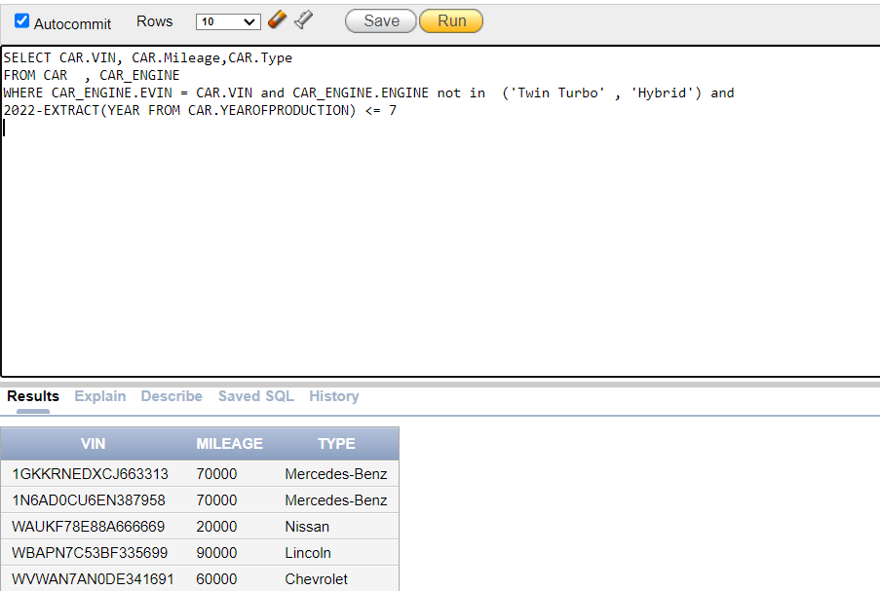

**Ouch!**

On November 1st of this year, Thaddus Cully rented an aquamarine Lincoln and then crashed it. AMA wants to know what type of insurance policy Thaddus has, if any, and who will handle the damages. If available, please provide the insurance ID; otherwise, return null.

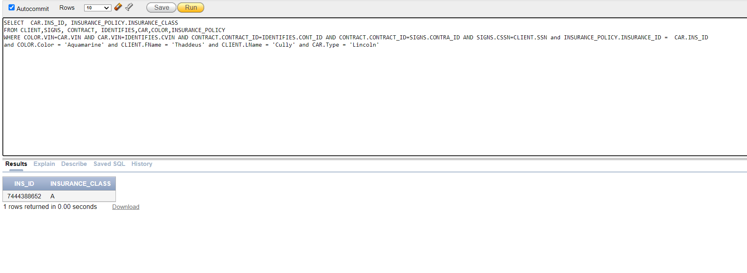

**They Grow Up So Fast!**

Every year, AMA determines which of its employees have reached the age of 64 and are therefore eligible for retirement and pension benefits. As a token of appreciation from AMA, if one of those employees has a dependent under the age of 18, they will receive a 20% bonus on their pension to help with the child's college tuition. Please obtain the full names of these employees, as well as the full names of any dependents under the age of 18, if available.

**Total Profit:**

AMA is selecting a dealership branch for the “Branch of the Year” award. The branch is chosen based on its profit for the year. As a result, AMA requires assistance in calculating the profits of each dealership branch. To assist AMA, create a query that displays the total profit of each dealership branch. 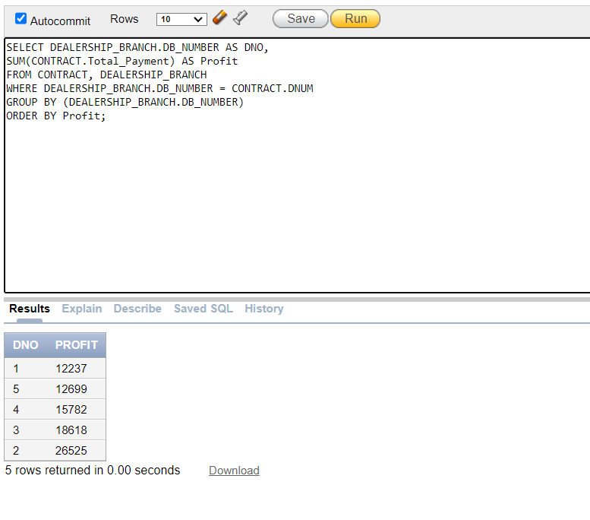

**What are the Odds?!**

Every year, AMA attempts to select a criterion at random for rewarding one of its employees. This year, AMA decided to reward all employees who share their supervisor's birthday and have the same first name as one of their dependents with a 10% bonus. Please obtain contact information for all employees who meet this criterion.

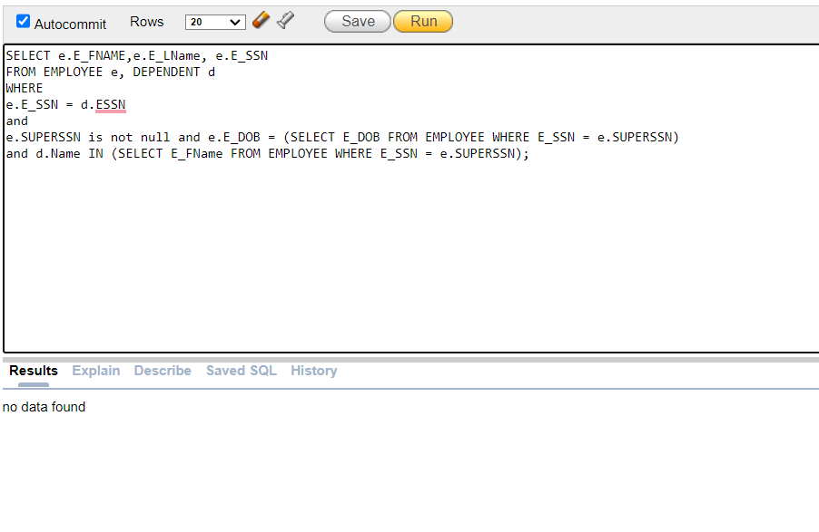

Oh well ☹

**Not Rented:**

After a successful holiday season, AMA rented a lot of cars from several dealerships. Please help them find the remaining cars that have not been rented yet across all the dealerships.

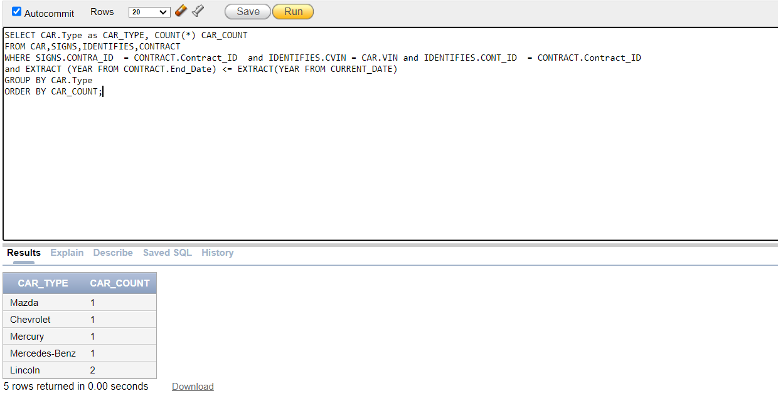

**Always Here for Help:**

This morning in New York, a car struck Ahmad Yaser. Ahmad is still alive, thanks to God. He only remembers the car being a black Honda and having a license plate ending in '123.' The police have asked the AMA Company for car information that matches the following description, as well as the name and SSN of the car renter if they exist.

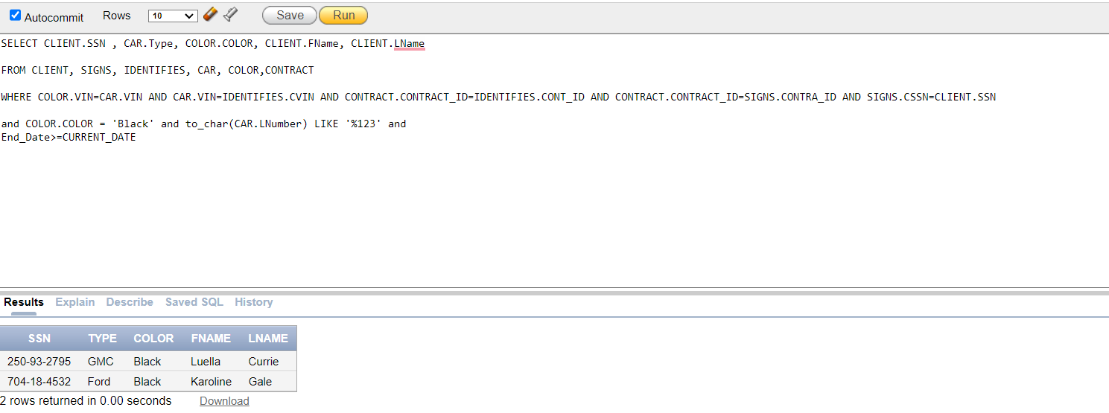

10- Normalization Up to the BCNF Form

After creating all relations, they should be improved by normalizing them according to the first 3 normal forms and the BCNF. Relations without non-prime attributes do not undergo normalization.

Each relation should satisfy the following conditions:

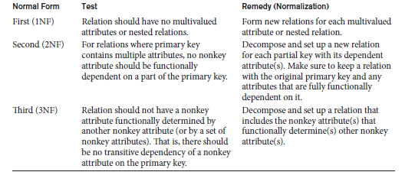

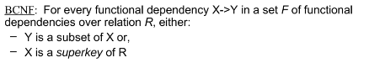

1. Employee Relation

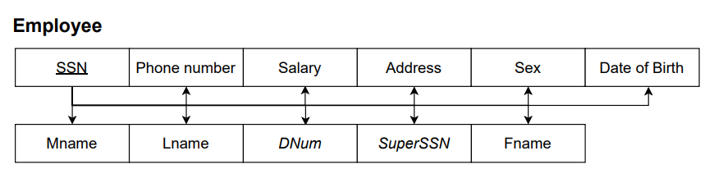

* The following relation satisfies all the conditions of the 1NF because all attributes are single and atomic.
* The following relation satisfies all the conditions of the 2NF because it satisfies the 1NF and all non-prime attributes are fully functionally dependent on the primary key SSN.
* The following relation satisfies all the conditions of 3NF because it satisfies the 2NF and there is no non-prime attribute that is transitively dependent on the primary key SSN.
* The following relation satisfies all the conditions of the BCNF because it satisfies the 3NF and there exists no functional dependency X 🡪 A where X is not a superkey and A is not a prime attribute.

1. Dealership_Branch Relation

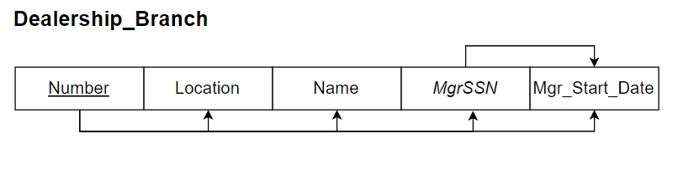

* The following relation satisfies all the conditions of the 1NF because all attributes are single and atomic
* The following relation satisfies all the conditions of the 2NF because it satisfies the 1NF and all non-prime attributes are fully functionally dependent on the primary key Number. (Which stands for the dealership number)
* The following relation does not satisfy all the conditions of 3NF. It satisfies the 2NF however, there is a functional dependency( MgrSSN 🡪 Mgr_Start_Date ) where neither MgrSSN is a superkey nor Mgr_Start_Date is a prime attribute. Thus, further decomposition is needed.

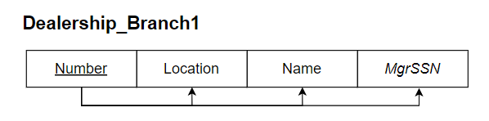

* After decomposition, the following relation satisfies all the conditions of the BCNF because it satisfies the 3NF and there exists no functional dependency X 🡪 A where X is not a superkey and A is not a prime attribute.

1. Client Relation

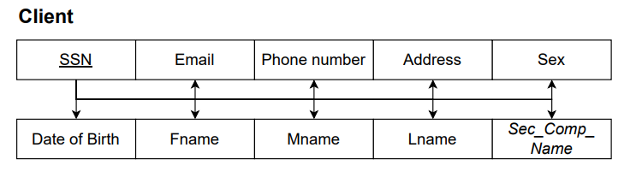

* The following relation satisfies all the conditions of the 1NF because all attributes are single and atomic.
* The following relation satisfies all the conditions of the 2NF because it satisfies the 1NF and all non-prime attributes are fully functionally dependent on the primary key SSN.
* The following relation satisfies all the conditions of 3NF because it satisfies the 2NF and there is no non-prime attribute that is transitively dependent on the primary key SSN.
* The following relation satisfies all the conditions of the BCNF because it satisfies the 3NF and there exists no functional dependency X 🡪 A where X is not a superkey and A is not a prime attribute.

1. Contract Relation

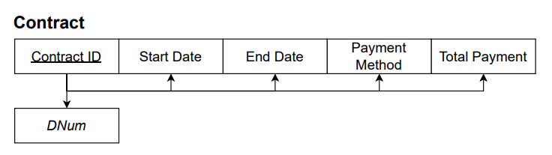

* The following relation satisfies all the conditions of the 1NF because all attributes are single and atomic.
* The following relation satisfies all the conditions of the 2NF because it satisfies the 1NF and all non-prime attributes are fully functionally dependent on the primary key Contract_ID.
* The following relation satisfies all the conditions of 3NF because it satisfies the 2NF and there is no non-prime attribute that is transitively dependent on the primary key SSN.
* The following relation satisfies all the conditions of the BCNF because it satisfies the 3NF and there exists no functional dependency X 🡪 A where X is not a superkey and A is not a prime attribute.

1. Car Relation

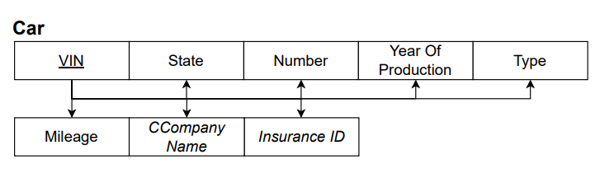

* The following relation satisfies all the conditions of the 1NF because all attributes are single and atomic.
* The following relation satisfies all the conditions of the 2NF because it satisfies the 1NF and all non-prime attributes are fully functionally dependent on the primary key VIN.
* The following relation satisfies all the conditions of 3NF because it satisfies the 2NF and there is no non-prime attribute that is transitively dependent on the primary key VIN.
* The following relation satisfies all the conditions of the BCNF because it satisfies the 3NF and there exists no functional dependency X 🡪 A where X is not a superkey and A is not a prime attribute.

1. Supplier Relation

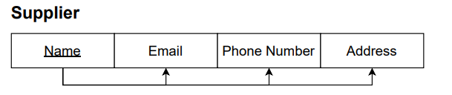

* The following relation satisfies all the conditions of the 1NF because all attributes are single and atomic.
* The following relation satisfies all the conditions of the 2NF because it satisfies the 1NF and all non-prime attributes are fully functionally dependent on the primary key Name.
* The following relation satisfies all the conditions of 3NF because it satisfies the 2NF and there is no non-prime attribute that is transitively dependent on the primary key Name.
* The following relation satisfies all the conditions of the BCNF because it satisfies the 3NF and there exists no functional dependency X 🡪 A where X is not a superkey and A is not a prime attribute.

1. Maintenance_Compnay Relation

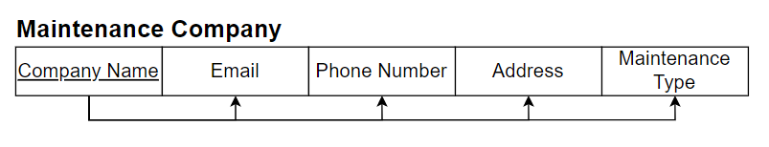

* The following relation satisfies all the conditions of the 1NF because all attributes are single and atomic.
* The following relation satisfies all the conditions of the 2NF because it satisfies the 1NF and all non-prime attributes are fully functionally dependent on the primary key Company_Name.
* The following relation satisfies all the conditions of 3NF because it satisfies the 2NF and there is no non-prime attribute that is transitively dependent on the primary key Company_Name.
* The following relation satisfies all the conditions of the BCNF because it satisfies the 3NF and there exists no functional dependency X 🡪 A where X is not a superkey and A is not a prime attribute.

1. Cleaning_Company Relation

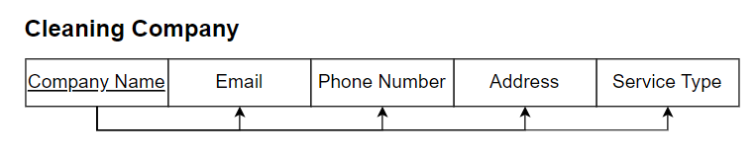

* The following relation satisfies all the conditions of the 1NF because all attributes are single and atomic.
* The following relation satisfies all the conditions of the 2NF because it satisfies the 1NF and all non-prime attributes are fully functionally dependent on the primary key Company_Name.
* The following relation satisfies all the conditions of 3NF because it satisfies the 2NF and there is no non-prime attribute that is transitively dependent on the primary key Company_Name.
* The following relation satisfies all the conditions of the BCNF because it satisfies the 3NF and there exists no functional dependency X 🡪 A where X is not a superkey and A is not a prime attribute.

1. Shipping_Company Relation

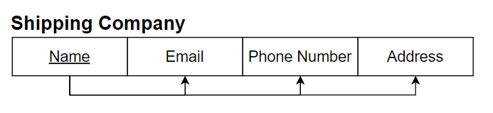

* The following relation satisfies all the conditions of the 1NF because all attributes are single and atomic.
* The following relation satisfies all the conditions of the 2NF because it satisfies the 1NF and all non-prime attributes are fully functional dependent on the primary key Name.
* The following relation satisfies all the conditions of 3NF because it satisfies the 2NF and there is no non-prime attribute that is transitively dependent on the primary key Name.
* The following relation satisfies all the conditions of the BCNF because it satisfies the 3NF and there exists no functional dependency X 🡪 A where is not a superkey and A is not a prime attribute.

1. Security Company Relation

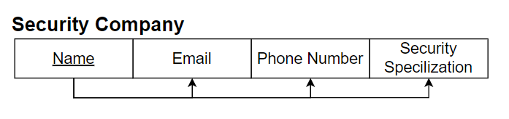

* The following relation satisfies all the conditions of the 1NF because all attributes are single and atomic.
* The following relation satisfies all the conditions of the 2NF because it satisfies the 1NF and all non-prime attributes are fully functionally dependent on the primary key Name.
* The following relation satisfies all the conditions of 3NF because it satisfies the 2NF and there is no non-prime attribute that is transitively dependent on the primary key Name.
* The following relation satisfies all the conditions of the BCNF because it satisfies the 3NF and there exists no functional dependency X 🡪 A where X is not a superkey and A is not a prime attribute.

1. Insurance Policy Relation

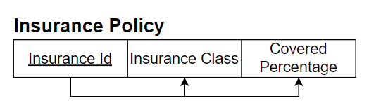

* The following relation satisfies all the conditions of the 1NF because all attributes are single and atomic.
* The following relation satisfies all the conditions of the 2NF because it satisfies the 1NF and all non-prime attributes are fully functionally dependent on the primary key Insurance_Id.
* The following relation satisfies all the conditions of 3NF because it satisfies the 2NF and there is no non-prime attribute that is transitively dependent on the primary key Insurance_Id.
* The following relation satisfies all the conditions of the BCNF because it satisfies the 3NF and there exists no functional dependency X 🡪 A where X is not a superkey and A is not a prime attribute.

1. Dependent Relation

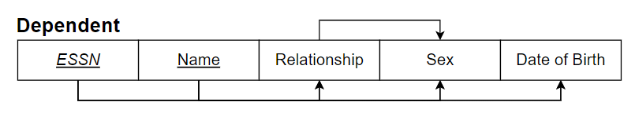

* The following relation satisfies all the conditions of the 1NF because all attributes are single and atomic.
* The following relation satisfies all the conditions of the 2NF because it satisfies the 1NF and all non-prime attributes are fully functional dependent on the primary key {ESSN, Name}.
* The following relation doesn’t satisfy all the conditions of 3NF. It satisfies the 2NF however, there is a functional dependency Relationship 🡪 Sex where neither Relationship is a superkey nor Sex is a prime attribute. Thus, further decomposition is needed.

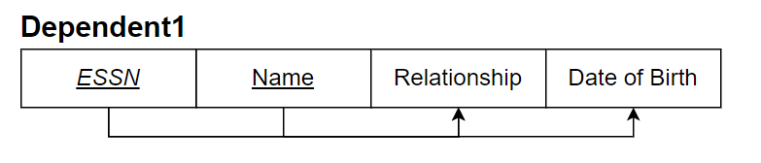

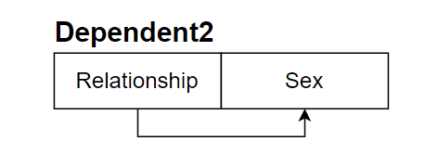

* After decomposition, the following relation satisfies all the conditions of the BCNF because it satisfies the 3NF and there exists no functional dependency X 🡪A where X is not a superkey and A is not a prime attribute.

1. Signs Relation

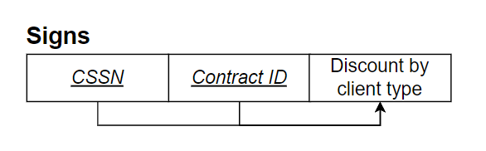

* The following relation satisfies all the conditions of the 1NF because all attributes are single and atomic.
* The following relation doesn’t satisfy all the conditions of the 2NF because not all non-prime attributes are fully functionally dependent on the primary key {CSSN, Contract_ID}. In this relation, if CSSN is dropped, the functional dependency still holds. Thus, further decomposition is needed.

* After decomposition, the following relation satisfies all the conditions of 3NF because it satisfies the 2NF and there is no non-prime attribute that is transitively dependent on the primary key {CSSN, Contract_ID}.
* The following relation satisfies all the conditions of the BCNF because it satisfies the 3NF and there exists no functional dependency X 🡪 A where X is not a superkey and A is not a prime attribute.

1. Supplies Relation

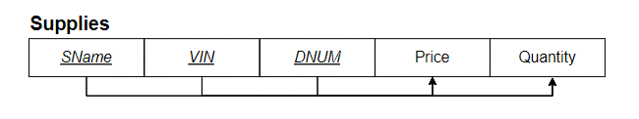

* The following relation satisfies all the conditions of the 1NF because all attributes are single and atomic.
* The following relation doesn’t satisfy all the conditions of the 2NF because not all non-prime attributes are fully functionally dependent on the primary key {SName, VIN, DNUM}. In this relation, if DNUM is dropped, the functional dependency still holds. Thus, further decomposition is needed.

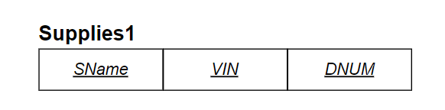

* After decomposition, the following relation satisfies all the conditions of 3NF because it satisfies the 2NF and there is no non-prime attribute that is transitively dependent on the primary key {SName, VIN, DNUM}.
* The following relation satisfies all the conditions of the BCNF because it satisfies the 3NF and there exists no functional dependency X 🡪 A where X is not a superkey and A is not a prime attribute.

1. Relation Schemas without Non-prime attributes

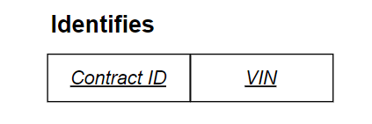

11-Conclusion

In phase 4 we conclude our car rental company project. During this phase, the ER relations were normalized using the first three normal forms, as well as the Boyce Codd normal form (BCNF). The latter was done to try to avoid redundancy and maximize efficiency in order to create what we think will be a "good" database.

12-Instructer’s feedback

13-Refrences

Wikipedia contributors. (2022, September 21). *Car rental*. Wikipedia. Retrieved October 23, 2022, from <https://en.wikipedia.org/wiki/Car_rental>

Cromer, O. C. (2022, October 6). *automobile | Definition, History, Industry, Design, & Facts*. Encyclopedia Britannica. Retrieved October 23, 2022, from <https://www.britannica.com/technology/automobile>

https://www.slideshare.net/SandeepChhabra12/bcnf-vs-3nf

Al Masri Book.

https://alg.manifoldapp.org/read/introduction-to-database-systems/section/039a1438-ece4-4917-9596-254de7d52fd6#:~:text=Mapping%20an%20Entity%20Relationship%20(ER,the%20relationship%20between%20its%20members.

Dummy data was generated using: mockaroo.com